Predict the Weather using a Weather Map

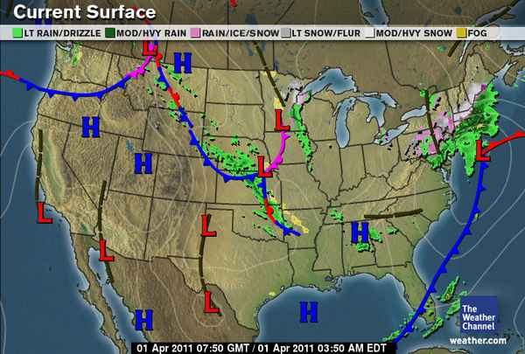
- What is the weather like in Utah?
_________________________________________________________________
- What parts of the map did you use to make your prediction?

- What is the weather like in California?
_________________________________________________________________
- What parts of the map did you use to make your prediction?

- What is the weather like in New York?
_________________________________________________________________
- What parts of the map did you use to make your prediction?

