**Study Guide for NINEWEEKS TEST & TCAP**



**Scientific Method**

1. **Scientific Methods – are ways scientists follow steps to answer a question or solve a problem**



1. **Hypothesis – a possible explanation or guess to the question or problem**
2. **Controlled experiment – Tests on ONE factor at time – with a control (Does not get the change) to compare to**
3. **Scientific Method:**
   1. **Make an observation to ask a Question**
   2. **Make an Hypothesis**
   3. **Do an experiment**
   4. **Record and Analyze the Data**
   5. **Make a Conclusion**
   6. **Share your results**

**Engineering Design Process**

1. **My RESULTS DEPENDS on What I CHANGE (independent variable)**
2. **Variable – any factor or part that can affect an experiment ( examples: cup, fish, amount of water, ice)**
3. **Independent Variable – What “I” change in an experiment**
4. **Dependent Variable – The RESULT of what I change**
5. **Experimental Group – The Group That gets the CHANGE**
6. **Control – The group or part that DOES NOT get the change and used to compare to**
7. **Trial – Repeating the experiment, each time the experiment is done is called a trial**
8. **Engineering Design Process Steps**
   1. **Ask (what is the problem or question)**
   2. **Imagine (the answer to the problems or question)**
   3. **Plan and create (draw a blueprint or design – the build the prototype)**
   4. **Improve – What changes can you make**

**Technology**

1. **Assistive Technology – HELPS the organism (Glasses, canes, inhalers, walkers)**
2. **Adaptive Technology – CHANGES the organism Permanently or lifestyle change Permanently (laser eye surgery , insulin pumps, knee replacement, doorbell light for the deaf)**

**Conclusions**

1. **Must support or NOT Support the Hypothesis**
2. **A Valid conclusion is one that can be trusted**
   1. **Experiment should be repeated many times with same results**
   2. **The experiment should be repeated by others**

**Bias and Error**

1. **Error can happen when:**
   1. **Wrong measurements**
   2. **Using the wrong scientific tools**
   3. **Changing the conditions (like the temperature in the room of the experiment)**
2. **Bias is an expectation that leads to a particular conclusion**
   1. **May be something in the unconscious (back of mind)**
   2. **Person may not want to be wrong**
   3. **Misrepresentation of Data**
   4. **Opinion**
   5. **Past experiences**

**Scientific Tools**

1. **Metric System**
   1. **Kilo, Hecto, Deka { BASE UNIT (meter, liter, gram)}, Deci, Centi, Milli**
   2. **King Henry Doesn’t Usually Drink Chocolate Milk**
   3. **Celsius Temperatures:** 
      1. **Thirty is hot**

**Twenty is nice**

**Ten is cool**

**Zero is ICE!**

1. **Tools**
   1. **Beaker – to measure or mix liquids or pourable solids**
   2. **Gradated cylinders – to measure liquids**
   3. **Balance scale – to compare two measures or compare one item to a given weight**
   4. **Meter stick – to measure length**
   5. **Thermometer – to measure temperature**
   6. **Microscope – to view TINY objects**
   7. **Telescope – to view objects FAR AWAY**

**Interactions of Living Things**

1. **Biotic – LIVING Things**
2. **Abiotic – NON – LIVING Things**
3. **Limiting Factors** – **resource that is SO SCARCE that it limits the size of the Population**
   1. **(Examples:** food, water, living space…)
4. **Carry Capacity – the largest population that an environment can support**
5. **Producers – PLANTS – make their own food through PHOTOSYNTHESIS**
6. **Consumers – EAT plants or other consumers**
   1. **Primary Consumers – Eat PLANTS**
   2. **Secondary Consumers – Eat animals that EAT Plants**
   3. **Third Consumers – Usually top of the food chain**
   4. **Fourth Consumers – Usually decomposers (EXAMPLES: FUNGI, MUSHROOMS, BACTERIA, WORMS, SLUGS, SNAILS)**

**Energy Flow**

1. **The ARROWS point to the one doing the EATING!**
2. **FOOD CHAIN - ONE line only**
3. **FOOD WEB – many food chains together – looks like a web**
4. **Energy Pyramid – a model for how the energy spreads through an ecosystem**

**Fourth level**-Decomposers and Scavengers

**Third level Consumers**- Omnivores

**Second Level Consumers** – Carnivores

**First Level Consumers** – Herbivores

**Producers** - Plants

**ENERGY Passed from one level to the next is about 10% - the other 90% is used to survive!**

**Levels of the Environment**

1. **Organism – only ONE**
2. **Population – Two or more of the same animal/plant**
3. **Community – many populations in a given area**
4. **Ecosystem – a community and its NON-LIVING (Abiotic) parts**
5. **Biome – Ecosystems that have similar climate, animals, & plants**
6. **Biosphere – All the ecosystems of the earth**

**Adaptations**

1. **Camouflage**
2. **Warning Coloration**
3. **Teeth adaptations**
4. **Feet adaptations**
5. **Beak adaptations**
6. **Behavioral adaptations**
7. **Communication**

**KNOW EXAMPLES OF THESE!!!!**

**Symbiosis**

1. **Mutualism – BOTH Benefit/HELPED**
2. **Commensalism – ONE Benefits – other is UNAFFECTED**
3. **Parasitism – ONE Benefits – other is HURT**

**Consumers = EATERS**

1. **Predator – Hunts and Eats**
2. **Prey – Being Hunted and is Eaten**

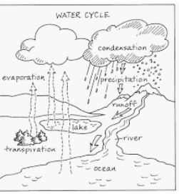

**Cycles**

1. **Water Cycle**
   1. **Evaporation – Turn liquid water to a GAS**
   2. **Condensation – Turns Gas back into a LIQUID – Makes CLOUDS**
   3. **Precipitation – Clouds can NOT hold any more water – it falls as rain , snow, sleet, or hail**
   4. **Transpiration – The waste of Plants that releases WATER into the Air**
2. **Carbon Cycle (ALL living things contain carbon and need carbon – some nonliving things also are made of carbon)**
   1. **Carbon is released for plants to use by:**
      1. **Respiration – the breathing in of oxygen by animals and used to break down sugar and exhaling – CARBON DIOXIDE**
      2. **Combustion – the burning of things that releases CARBON**
      3. **Decomposition – Decomposers breaking down dead plants and animals and releasing CARBON in the soil**
   2. **Animals and HUMANS get the carbon they need by EATING PLANTS or animals that have eaten plants**
3. **Nitrogen Cycle – ALL living things need nitrogen but can NOT use Nitrogen GAS**
   1. **PLANTS need nitrogen FIXED (3 ways to do)**
      1. **Lightning will FIX Nitrogen**
      2. **Bacteria will FIX Nitrogen**
      3. **Decomposition will FIX Nitrogen**
   2. **Animals and HUMANS get the Nitrogen they need by EATING PLANTS or animals that have eaten plants**

Factors that determine Biome: Climate, Latitude, Elevation, Precipitation, Animals, and Plants

**Biomes**

1. **Tundra – COLD Desert – at the poles or tops of mountains, less than 10 in rain**
2. **Taiga – Coniferous Forest – Evergreen Trees – Right below the Tundra at the poles**
3. **Temperate Deciduous Forest – SEASONS – Leaves fall in the FALL- makes very RICH Soil**
4. **Rainforest – At the EQUATOR – NO Seasons – always summer – POOR Soil due to no leaves falling in fall**
5. **Desert – Less than 25 cm or 10 inches of rain- Extreme temperatures , hot = day, cold = night, poor soil, animals adapt to live there**
6. **Grasslands – Grasses very few trees, found in all over the earth, RICH SOIL**
   1. **Prairie – North America**
   2. **Steepe – Asia**
   3. **Savannas – Africa**
   4. **Pampas – South America**
7. **Freshwater Biomes – little or no salt content, includes flowing and standing water**
   1. **Flowing freshwater – rivers or streams**
   2. **Standing freshwater – ponds or lakes**
      1. **Wetlands - home to many plants and animals (also called a swamp)**

**8. Saltwater Biomes**

* 1. **Coral Reefs – formed from dead skeletons of coral over a long period of time**
     1. **Home of a large DIVERSE of plants and animals (Nemo!)**
  2. **Ocean – 4 zones**
     1. **Intertidal /Sunlight– contains the shoreline / coast (high and low tides)**
     2. **Neritic Zone/Twilight– still receives sunlight, water still warm, plants and marine animals**
     3. **Oceanic Zone/Midnight–Sea floor drops sharply, plankton near surface**
     4. **Benthic Zone- Deepest part of the ocean – no sunlight at the ocean floor, some animals get energy from thermal vents**
  3. **Estuaries- Where FRESHWATER and SALT WATER Meet! - Contains most of OUR SEAFOOD, very rich in nutrients**

**Communication**

**Animals communicate in the following ways:**

1. **Auditory** Signals: Bird songs, roars, chirps, chatter, trumpets, rumbling, signal calls, contact calls, howling, hooting, hissing, whistling, and echolocation

2. **Chemical**: Sprays, marking territory, stings, smells

3. **Movements**: touching, flicking tails, entwining, baring teeth, rubbing, dancing, leaping, lowering bodies, waving body parts,

4. **Bright colors** – to warn predators, attract mates

5. **Physical** – structural change to help in survival, badges, displays,

6. **Behavioral** – hunt and catch, pretending to be dead,

7. **Tactile** – rubbing each other or people, grooming, nudging

**Biodiversity**

**Bio = Living and Diversity = Many** (**The number of species of plant and animals in a Biome)**

**The Higher the Biodiversity in an Ecosystem – the MORE STABLE the Ecosystem!!!**

**ALSO – When the BIOVERSITY is HIGH- losing a species will not affect as much if the Biodiversity is low!**

**Examples of BIODIVERSITY LOSS:**

**Fire Urbanization Natural Disasters**

**Overfishing Cities Floods**

**Poaching Farmland Hurricanes/Tornadoes**

**Invasive Species Disease Drought**

**Deforestation Pollution Tsunami**

**Over hunting Climate Change Volcanic eruptions**

**Strip Mining Pesticides / Herbicides Fertilizer Run off**

**\*\*\*\* ***HUMAN ACTIVITIES CAN CHANGE EARTH’S LAND, WATER, AIR, & LIFE!!!**

**Examples how BIODIVERSITY LOSS ---- AFFECTS HUMANS**

**Loss of Food Greenhouse Effect**

**Loss of Medicines Global Warming**

**Loss of Water Erosion of Soil**

**Loss of Natural Resources Acid Rain**

**Disease**

**Loss of Services in the Biome (Water Cycle/Photosynthesis Etc…)**

**Loss of Recycling of Nutrients (Decomposition)**

**Loss of Water Purification (Water Cycle)**

**Animal and plant Extinctions**

**ONCE A Biome reaches its carrying capacity for each species – the Biome is BALANCED!!**

**LOOK FOR SOLUTIONS TO BIODIVERSITY LOSS OR IMPACTS THAT WILL HELP RESTORE THE EQUAILIBIUM TO THE BIOME!!!**

**Conservation- the PROTECTION of things found in nature**

**Habitat Management – IMPROVE the existing habitat to benefit the wildlife there**

**Species Endangerment – An organisms threatened by extinction**

**Extinction – the termination or complete death of an organism**

**Ways Humans can lessen Negative Impact on Ecosystems**

**Reduce Reuse Recycle**

**Limits on Fishing and Hunting Treaties with other countries for limits**

**National / State Parks to reduce Deforestation**

**Use Cloth Bags for shopping Carpool, Walk, or Bike to work/school**

**Use Alternative Energy Sources- Wind, Solar, Hydro/Water, Biofuels, Hybrid Cars**

**Use more native species to help reduce impact of Invasive Species**

**Terrace Farming No Till Farming Hedgerows around crops**

**Resources**

**Renewable (Replaced Quickly) : Wind, Solar, Nuclear, Water/Hydro, Biomass**

**Nonrenewable (Not Replaceable in your lifetime): Fossil Fuels—Coal, Oil, Petroleum, Gasoline, Natural Gas, Diesel Fuel**

**Succession - Ecological**

**Primary – Begins with Rock – NO SOIL ---- Takes longer to reach Maturity/Climax**

**(Happens after Volcanic eruptions, glaciers, or when all soil has been removed)**

**Secondary – Soil is present – recovers quickly --- Maturity/Climax in about 150 yr.**

**(Happens after fires, floods, deforestation, etc…)**

**Example of a Food Chain**

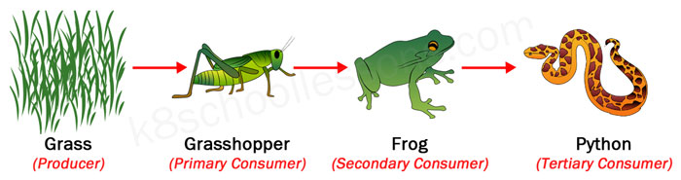**APEX Predator**

**Example of a Food Web:**

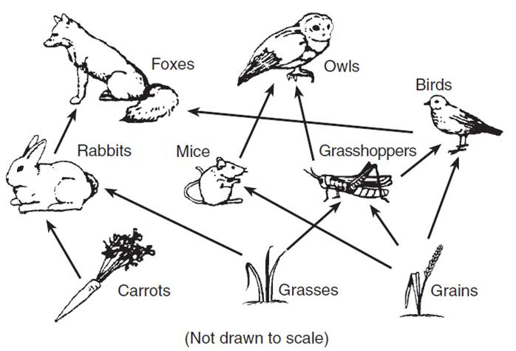

**ALL Food Webs and Food Chains begin with a PRODUCER!!**

**\*\*\*LIVING THINGS INTERACT WITH THEIR ENVIRONMENT!!!**

**\*\*\* EARTH IS A WATER PLANET!!!**

**\*\*\* EARTH’S LAND, WATER, AIR, AND LIFE FORM A SYSTEM!**

**3 Ways that Heat is transferred in the Atmosphere**

1. **Conduction** = transfer through **direct contact** --- **TOUCH**
2. **Convection** = the transfer **through AIR or WATER**
3. **Radiation** = the transfer through **SPACE** from the sun **ON AN EM WAVE**

**EM WAVES**: microwave, radio, infrared, light, UV, X-ray, Gamma

**Temperature**

1. **Temperature is the movement of (heat) particles** in the air, water, substances, and space
2. There are 3 scales used to measure temperature
   1. **Fahrenheit** = used in the US
      1. 32 ⁰F = Freezing
      2. 212⁰F = Boiling
      3. **72⁰F = Room Temperature**
   2. **Celsius** = a part of the metric system and used by scientists all around the world
      1. 0⁰ C = Freezing
      2. 100 ⁰C = Boiling
      3. **22⁰C = Room Temperature**
         1. **Thirty is Hot**
         2. **Twenty is Nice**
         3. **Ten is Cool**
         4. **Zero is Ice**
   3. **Kelvins** is used to measure extremely hot temperatures (Stars) or extremely cold temperatures (Deep Space)

**HEAT FLOW ---- MOVES FROM ------ HOT TO COLD!!**

**Energy** is the ability to DO Work or Move an Object

**Energy**

**Kinetic Energy** = Energy of movement / Motion

**Potential Energy** = Energy at rest or position

3 TYPES OF POTENTIAL ENERGY

**Gravitational Potential** (**GPE)** = Potential energy Due to HEIGHT

**Elastic Potential** = Potential energy Due to an object being STRETCHED or COMPRESSED

**Chemical Potential** = Potential energy Due to chemical BONDS

**Mechanical Energy** – is the total Kinetic and Potential Energy that does a Work

**As Kinetic Energy goes up = Potential Energy goes down**

**AND As Potential Energy goes up Kinetic Energy goes down**

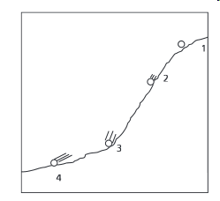 **Greatest GPE at position 1**

**Greatest Kinetic at position 4 (The Lines from the ball tell that it is still moving!)**

**FORMS OF ENERGY: (Mrs Chen)**

**Mechanical = all kinetic & potential used to move an object or do a job**

**Radiant = Light**

**Sound = Energy of vibrations**

**Chemical = Energy of Bonds (Food, Fossil Fuels, Batteries, & Living things)**

**Heat = Energy of movement of atoms (aka Thermal)**

**Electrical = Energy of moving electrons**

**Nuclear = Energy released by fission (splitting one nucleus) and fusion (smashing two nuclei together)**

**\*\*\*\*\*\*\*\*\*\*\*\*\*\*\*\*\*Law of Conservation of Energy:\*\*\*\*\*\*\*\*\*\*\*\*\*\*\*\*\***

**ENERGY IS NOT CREATED OR DESTROYED – IT ONLY CHANGES FORM**

**NOT CREATED NOT DESTROYED**

**\*\*Energy can take/change different forms but is always CONSERVED (SAME AMOUNT)**

**When added up together!!!!**

**Energy Transformations**

**Examples: Flashlight = Chemical Electrical Radiant (light) AND Thermal (Heat)**

**Campfire = Chemical Light Thermal (Heat)**

**Roller Coaster = GPE Kinetic (Mechanical)**

**KE (Kinetic Energy) = Mass x Velocity (Speed)2 KE = M *V2**

**2 2**

**If you Double the MASS ---- It will Double the IMPACT**

**If you SQUARE the MASS ---- It will Result in FOUR (4) Times the IMPACT**

**Graphs**

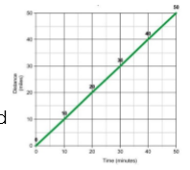 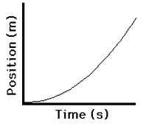

**Steady / Constant Speed Acceleration**

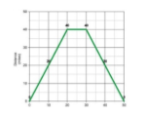 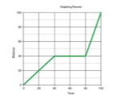

**Constant Speed – Stopped- Returned Back Constant Speed, Stopped, Faster**

**Constant Speed**

**Electricity**

**Current Electricity = The Flow of electrons in a conductor**

**Two types of Current:**

**AC = Alternating current from a generator (Found in all buildings)**

**DC = Direct Current from a BATTERY**

**Circuit – The Path the electricity flows through (Copper Wire or other metal objects)**

**Conductor – ALLOW Electrons to flow through – Most METALS**

**Insulator – DOES NOT allow Electrons to flow through - Glass, Plastic, rubber, cloth**

**Two Types of CIRCUITS**

**Series = ONE PATH 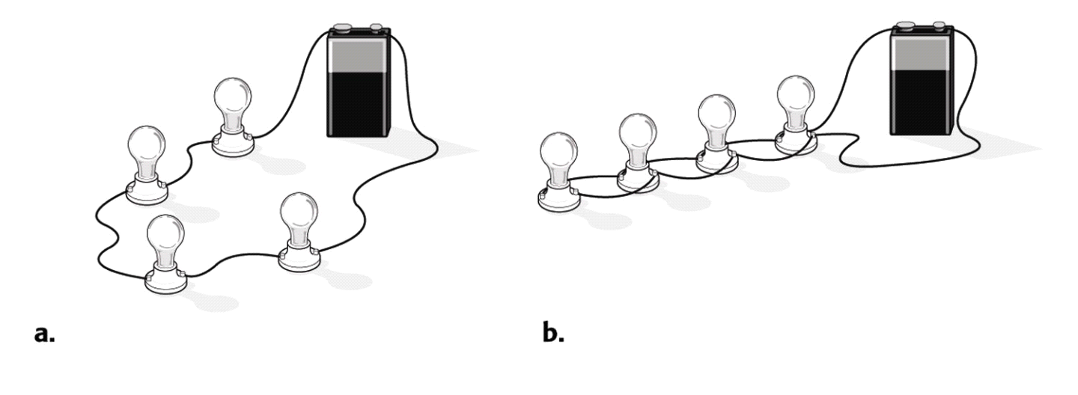One light goes out – THEY ALL GO OUT!**

**Parallel = At Least TWO (2) PATHS One light goes out, the Rest**

**STAY ON!!!!!**

**STATIC ELECTRICITY - The build of electrical charges (Positive or Negative) then how it discharges to balance the charges on two surfaces.**

**Example – Lightning**

**Clothes out of a dryer (Static Cling)**

**Scuffing feet on a carpet and touching a door knob or someone else**

**Circuits - Open Circuit the path has a gap or open switch- Electricity will NOT flow**

**Closed Circuit – the path is complete or switch is closed – Electricity CAN Flow**

**Energy Transformations in a Circuit**

**Example:**

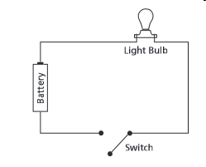**-**

Once the switch is closed – these are the transformations

1. Start with the Battery = **Chemical**
2. Turns into **Electrical**
3. Then **Light (Radiant)**
4. Finally **Heat/Thermal**

**\*IN ALL ENERGY TRANSFORMATION – HEAT IS ONE OF THE FORMS IN THE TRANSFORMATIONS**

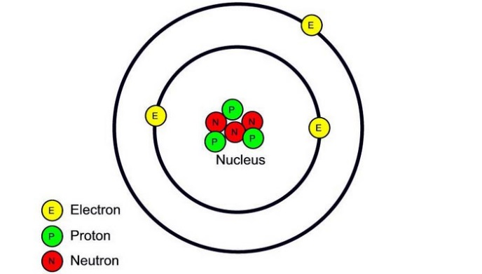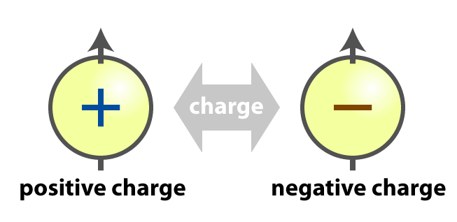

**Opposite** charges **ATTRACT** Each other

**Like** Charges **REPEL** each other

**\*\*\*\*THEREFORE – ELECTRONS (NEGATIVE) ARE ATTRACTED TO THE PROTON (POSITIVE)**

**VARIABLES:**

**\*\*\*\*\*\*\* My RESULTS * DEPENDS on What I CHANGE (independent variable)**

**Variable – any factor or part that can affect an experiment (examples: cup, fish, amount of water, ice)**

**Independent Variable – What “I” change in an experiment - ON PURPOSE!**

**Dependent Variable – The RESULT of what I change**

**Experimental Group – The Group That gets the CHANGE**

**Control – The group or part that DOES NOT get the change and used to compare to**

**Trial – Repeating the experiment, each time the experiment is done is called a tri**

**Layers of the Atmosphere**

1. Layers in order from Top Layer to the bottom layer:

5. **Exosphere** = Thinnest Layer – Satellites Orbit in this layer – gases may escape

4. **Thermosphere** = Hottest layer – Contains the Ionosphere that show the Auroras and Radio Waves Bounce off

3. **Mesosphere** = **middle l**ayer where meteors burn because of friction- Coldest layer

2. **Stratosphere** = The second layer that contains the **Ozone** layer that protects the earth from UV rays

1. **Troposphere** = The Bottom layer that **WE LIVE** in and **WEATHER occurs** (most planes Fly)

**\*\*\*\*\*\*\*\*\*\*\*\*\*\*The Screaming Monster Terrorized Everyone\*\*\*\*\*\*\*\*\*\*\*\*\*\*\*\*\***

**If the AIR MOVES – it is WIND -- Due to CONVECTION**

**Winds**

1. Winds are **created by the UNEVEN HEATING of the EARTH by the SUN**
   1. Types of winds (Named for the direction they come from = DUE TO THE COROLIS EFFECT)
      1. Prevailing --- **Polar Easterlies 60⁰ - 90⁰ latitude - At the POLES!**
      2. Prevailing --- **Westerlies (Has the most effect on US weather patterns) 5⁰ - 60⁰ latitudes**
      3. Prevailing --- **Trade Winds 5⁰ - 30⁰**
      4. **Doldrums** = NO or LITTLE Wind 0**⁰ - 5⁰**
      5. **JET STREAM** – Strong winds the ZIG ZAG Horizontally and affect the WEATHER in the US by MOVING the PREVAILING WIND PATTERNS

**Convection Current: Hot air/water Rises and Cold air/water sinks**

**Makes a circular path**

The

**Breezes**

1. **Sea Breeze = Occurs during the DAY**

1. Land Heats faster than the Sea
2. Hot air rises above the land, cool air from **the sea moves under the hot rising air**

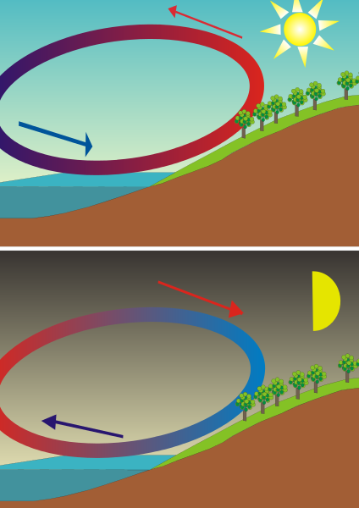

**2. Land Breeze** = **Occurs during the NIGHT**

1. Sea is warm from heating all day –
2. Heat will radiate off the sea and the cool air from the Land moves under the warm rising air



**Ocean Currents**

1. The Oceans have warm and cold currents due to the UNEVEN HEATING Of the EARTH’S SURFACE
   1. **Warm currents** Rise from the EQUATOR AND Move towards the POLES
      1. Example of Warm Current – **THE GULF STREAM**
   2. **Cold currents** sink at the POLES AND Move Towards the EQUATOR
      1. Example of Cold Current – **THE CALIFORNIA CURRENT / PERU-HUMBOLDT**
      2. **COLD Water is more DENSE** than Warm Water due to Cold Temperature and SALINITY (SALT)
2. The Coriolis Effect also affects the direction **SURFACE CURRENTS** travel, since surface currents are **carried AND Caused by the WIND**
3. **Rain shadows** are formed when warm moist air blows from the ocean and reach the **windward** side of a mountain and drops all its moisture on that side due to the air cooling as it moves up the windward side
4. **On the Leeward side** the air is dry and creates a **Rain shadow**  or desert

**Rain Shadow**

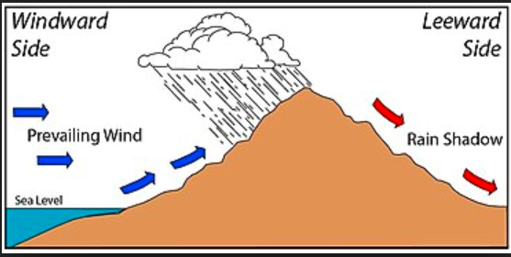

**Types of Air Masses**

Mp = Maritime Polar – Cold and Wet Cp = Continental Polar – Cold & Dry

Mt = Maritime Tropical – Warm and Wet Ct = Continental Tropical – Cold & Wet

**CLOUDS**

1. Clouds are form as WATER VAPOR CONDENSES on dust particles in the air
2. There are 3 Main Types of Clouds
   1. **STRATUS** = Low Clouds, look like a blanket
      1. **Nimbostratus** – Low gray to dark looking clouds
      2. Responsible for rain, snow, freezing rain, or sleet over a period of time
   2. **CUMULUS =** Middle level clouds that look like cotton balls – Puffy, fluffy, white in color
      1. Responsible for Fair Weather
      2. **CUMULONIMBUS** – Middle level, high stacking clouds, dark in color
         1. Responsible for **Thunderstorms, Hail, and Tornadoes**
   3. **Cirrus** – H**I**GH level clouds, look like light paint strokes, wispy, white clouds, made of **i**ce crystals
      1. Responsible for **FAIR Weather**

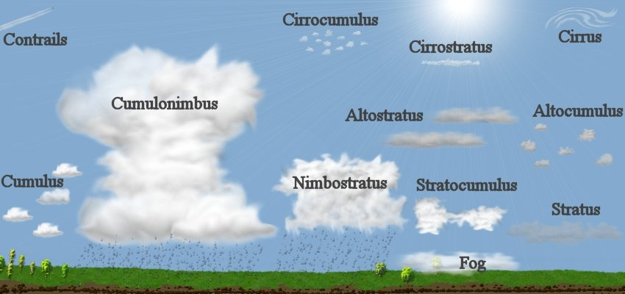

**To Predict the Weather:**

* + - 1. LOOK at **Type of CLOUDS**
         1. Cumulus – Fair
         2. Cumulonimbus – Thunderstorms, Hail, Winds
         3. Cirrus – Fair
         4. Stratus/White – Fair
         5. Nimbostratus – Rain, Sleet, Snow, Freezing Rain
      2. **Temperature –** IF above 32⁰ F / 0⁰ C --- THEN Rain

IF BELOW 32⁰ F / 0⁰ C --- THEN Snow, Freezing Rain or Sleet

* + - 1. **Air Pressure** 
         1. **Higher** number (to 31 in or 1050 mb) **GOOD** WEATHER
         2. **Lower** Number (to 28 in or 950 mb) **Rainy to SNOWY** Weather
         3. Pressure **DROPS QUICKLY=== STORM!!**
      2. **WIND** – MOST WEATHER IN THE US TRAVELS
         1. **WEST TO EAST** (Due to prevailing Westerlies)
         2. **WIND DETERMINES HOW FAST WEATHER MOVES**
      3. **PRESSURE SYSTEMS:**
         1. **HIGH (COLD)** Moves to  **LOW (WARM)**
      4. **Humidity** 
         1. **Closer to 100% - Rain/Snow**
         2. **Closer to 0% - Fair Weather**
      5. **DEWPOINT**
         1. Temperature where the air will condense –

Frost, Dew, Clouds, Precipitation

Occurs at 100% Relative Humidity!!

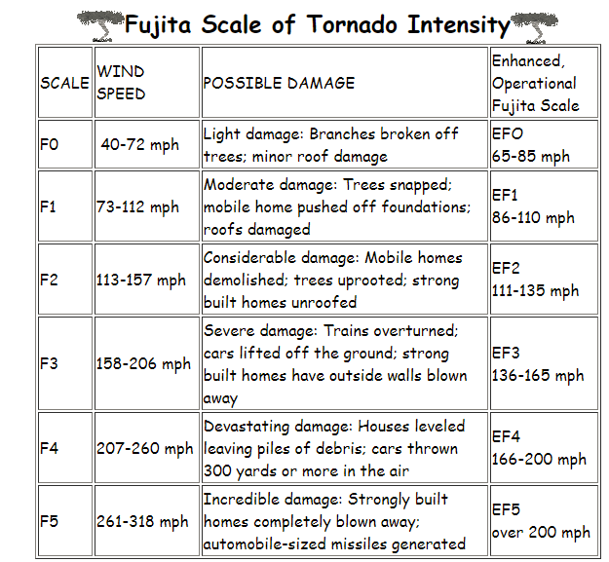

**Tornados form over land, during Thunderstorms.**

**Usually when a fast moving cold front meets a warm front**

**The larger the difference in temperature of the 2 meeting fronts, the stronger the storm and possible tornado will be!**

**Tornadoes can be formed within Hurricanes once they hit land.**

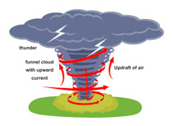

**Tornadoes** are extreme weather patterns that form **OVER LAND**, when:

*The sun heats the ground

*Warm air starts to rise but is held down by Cold Air

*Eventually the warm air finds a spot to rise (push) through the cold air

Creating a **Funnel cloud or Tornado**

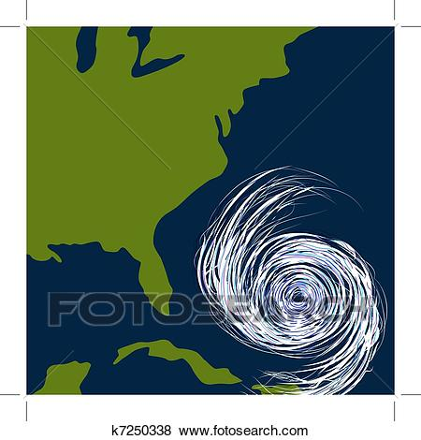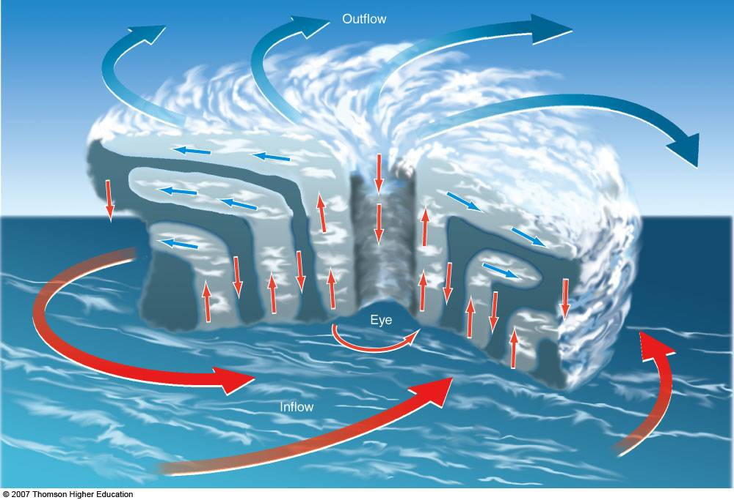

**Hurricane Formation**

**Hurricanes or Typhoons** are extreme weather patterns that **form over Warm ocean waters** (80⁰)

When WARMER air (Low Pressure) begins to rotate around a HIGH Pressure system (COOL air)

**Eye of the Hurricane – Calm -High pressure center**

|  |  |  |
| --- | --- | --- |
| **Saffir-Simpson Scale** | | |
| **Category** | **Wind - mph** | **Damage** |
| 5 | >157 | Catastrophic |
| 4 | 130-156 | Extreme |
| 3 | 111-129 | Extensive |
| 2 | 96-110 | Moderate |
| 1 | 74-95 | Minimal |
| Tropical Storm | 39-73 |  |
| Tropical Depression | < 38 |  |

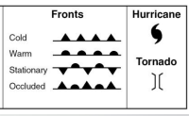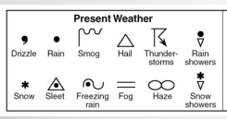

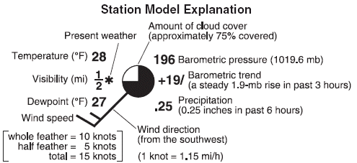

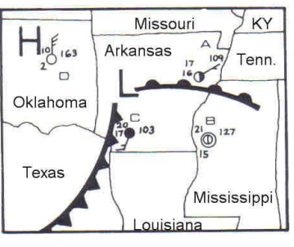

**Warm fronts** are the leading edge of warm air masses – will have slower longer rains, clouds

**Cold Fronts** are the leading edge of a cold air mass- leads to Thunderstorms and possible tornadoes

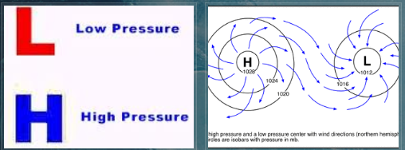

**High Pressure moves to Low Pressure**

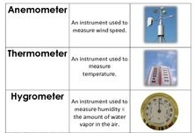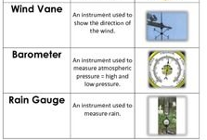

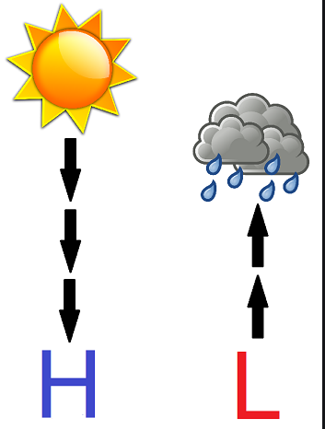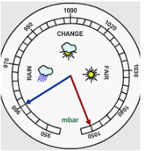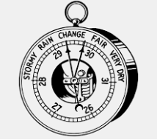

**H**

**L**

**High Pressure** = Cold/Cooler Air sinks because it is more dense

The **Front edge is cold front** – has the stormy-rainy weather

The High Pressure then, will clear/push everything out, for a **FAIR DAY**

**Low Pressure =** Warmer**,** moist air rises- has room for more moisture to accumulate in the atmosphere.

The **Front edge is warm front** – has clouds & rainy weather

The Low Pressure then will have **clouds with possible rain/snow**

C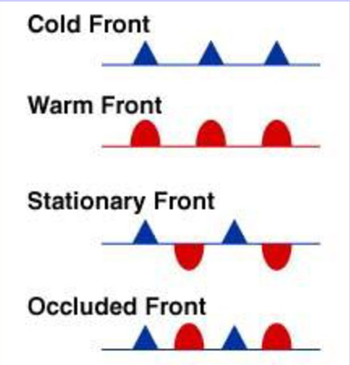

**Cold Front – leading edge of High Pressure - Stormy Weather on Front line**

**Warm Front – leading edge of Low Pressure – rainy /cloudy weather on Front line**

**Stationary Front - Cold and Warm fronts meet – going in opposite directions – Stopped**

**Occluded Front – Cold Front lifts up a Warm Front – going same direction**