**Study Guide for TCAP**



**Scientific Method**

1. **Scientific Methods – are ways scientists follow steps to answer a question or solve a problem**



1. **Hypothesis – a possible explanation or guess to the question or problem**
2. **Controlled experiment – Tests on ONE factor at time – with a control (Does not get the change) to compare to**
3. **Scientific Method:**
   1. **Make an observation to ask a Question**
   2. **Make an Hypothesis**
   3. **Do an experiment**
   4. **Record and Analyze the Data**
   5. **Make a Conclusion**
   6. **Share your results**

Engineering Design Process

1. **My RESULTS DEPENDS on What I CHANGE (independent variable)**
2. **Variable – any factor or part that can affect an experiment ( examples: cup, fish, amount of water, ice)**
3. **Independent Variable – What “I” change in an experiment**
4. **Dependent Variable – The RESULT of what I change**
5. **Experimental Group – The Group That gets the CHANGE**
6. **Control – The group or part that DOES NOT get the change and used to compare to**
7. **Trial – Repeating the experiment, each time the experiment is done is called a trial**
8. **Engineering Design Process Steps**
   1. **Ask (what is the problem or question)**
   2. **Imagine (the answer to the problems or question)**
   3. **Plan and create (draw a blueprint or design – the build the prototype)**
   4. **Improve – What changes can you make**

**Technology**

1. **Assistive Technology – HELPS the organism (Glasses, canes, inhalers, walkers)**
2. **Adaptive Technology – CHANGES the organism Permanently or lifestyle change Permanently (laser eye surgery , insulin pumps, knee replacement, doorbell light for the deaf)**

**Conclusions**

1. **Must support or NOT Support the Hypothesis**
2. **A Valid conclusion is one that can be trusted**
   1. **Experiment should be repeated many times with same results**
   2. **The experiment should be repeated by others**

**Bias and Error**

1. **Error can happen when:**
   1. **Wrong measurements**
   2. **Using the wrong scientific tools**
   3. **Changing the conditions (like the temperature in the room of the experiment)**
2. **Bias is an expectation that leads to a particular conclusion**
   1. **May be something in the unconscious (back of mind)**
   2. **Person may not want to be wrong**
   3. **Misrepresentation of Data**
   4. **Opinion**
   5. **Past experiences**

**Scientific Tools**

1. **Metric System**
   1. **Kilo, Hecto, Deka { BASE UNIT (meter, liter, gram)}, Deci, Centi, Milli**
   2. **King Henry Doesn’t Usually Drink Chocolate Milk**
   3. **Celsius Temperatures:** 
      1. **Thirty is hot**

**Twenty is nice**

**Ten is cool**

**Zero is ICE!**

1. **Tools**
   1. **Beaker – to measure or mix liquids or pourable solids**
   2. **Gradated cylinders – to measure liquids**
   3. **Balance scale – to compare two measures or compare one item to a given weight**
   4. **Meter stick – to measure length**
   5. **Thermometer – to measure temperature**
   6. **Microscope – to view TINY objects**
   7. **Telescope – to view objects FAR AWAY**

**Interactions of Living Things**

1. **Biotic – LIVING Things**
2. **Abiotic – NON – LIVING Things**
3. **Limiting Factors** – **resource that is SO SCARCE that it limits the size of the Population**
   1. **(Examples:** food, water, living space…)
4. **Carry Capacity – the largest population that an environment can support**
5. **Producers – PLANTS – make their own food through PHOTOSYNTHESIS**
6. **Consumers – EAT plants or other consumers**
   1. **Primary Consumers – Eat PLANTS**
   2. **Secondary Consumers – Eat animals that EAT Plants**
   3. **Third Consumers – Usually top of the food chain**
   4. **Fourth Consumers – Usually decomposers**

**Energy Flow**

1. **The ARROWS point to the one doing the EATING!**
2. **FOOD CHAIN - ONE line only**
3. **FOOD WEB – many food chains together – looks like a web**
4. **Energy Pyramid – a model for how the energy spreads through an ecosystem**

**Fourth level**-Decomposers and Scavengers

**Third level Consumers**- Omnivores

**Second Level Consumers** – Carnivores

**First Level Consumers** – Herbivores

**Producers** - Plants

**Levels of the Environment**

1. **Organism – only ONE**
2. **Population – Two or more of the same animal/plant**
3. **Community – many populations in a given area**
4. **Ecosystem – a community and its NON-LIVING (Abiotic) parts**
5. **Biosphere – All the ecosystems of the earth**

**Adaptations**

1. **Camouflage**
2. **Warning Coloration**
3. **Teeth adaptations**
4. **Feet adaptations**
5. **Beak adaptations**
6. **Behavioral adaptations**

**KNOW EXAMPLES OF THESE!!!!**

**Symbiosis**

1. **Mutualism – BOTH Benefit/HELPED**
2. **Commensalism – ONE Benefits – other is UNAFFECTED**
3. **Parasitism – ONE Benefits – other is HURT**
4. **Predator – Hunts and Eats**
5. **Prey – Being Hunted and is Eaten**

**Cycles**

1. **Water Cycle**
   1. **Evaporation – Turn liquid water to a GAS**
   2. **Condensation – Turns Gas back into a LIQUID – Makes CLOUDS**
   3. **Precipitation – Clouds can NOT hold any more water – it falls as rain , snow, sleet, or hail**
   4. **Transpiration – The waste of Plants that releases WATER into the Air**
2. **Carbon Cycle (ALL living things contain carbon and need carbon – some nonliving things also are made of carbon)**
   1. **Carbon is released for plants to use by:**
      1. **Respiration – the breathing in of oxygen by animals and used to break down sugar and exhaling – CARBON DIOXIDE**
      2. **Combustion – the burning of things that releases CARBON**
      3. **Decomposition – Decomposers breaking down dead plants and animals and releasing CARBON in the soil**
   2. **Animals and HUMANS get the carbon they need by EATING PLANTS or animals that have eaten plants**
3. **Nitrogen Cycle – ALL living things need nitrogen but can NOT use Nitrogen GAS**
   1. **PLANTS need nitrogen FIXED (3 ways to do)**
      1. **Lightning will FIX Nitrogen**
      2. **Bacteria will FIX Nitrogen**
      3. **Decomposition will FIX Nitrogen**
   2. **Animals and HUMANS get the Nitrogen they need by EATING PLANTS or animals that have eaten plants**

**Biomes**

1. **Tundra – COLD Desert – at the poles or tops of mountains**
2. **Taiga – Coniferous Forest – Evergreen Trees – Right below the Tundra at the poles**
3. **Temperate Deciduous Forest – SEASONS – Leaves fall in the FALL- makes very RICH Soil**
4. **Rainforest – At the EQUATOR – NO Seasons – always summer – POOR Soil due to no leaves falling in fall**
5. **Desert – Less than 25 cm or 10 inches of rain- Extreme temperatures , hot = day, cold = night, poor soil, animals adapt to live there**
6. **Grasslands – Grasses very few trees, found in all over the earth, RICH SOIL**
   1. **Prairie – North America**
   2. **Steepe – Asia**
   3. **Savannas – Africa**
   4. **Pampas – South America**
7. **Freshwater Biomes – little or no salt content, includes flowing and standing water**
   1. **Flowing freshwater – rivers or streams**
   2. **Standing freshwater – ponds or lakes**
      1. **Wetlands - home to many plants and animals (also called a swamp)**
8. **Saltwater Biomes**
   1. **Coral Reefs – formed from dead skeletons of coral over a long period of time**
      1. **Home of a large DIVERSE of plants and animals (Nemo!)**
   2. **Ocean – 4 zones**
      1. **Intertidal – contains the shoreline / coast (high and low tides)**
      2. **Neritic Zone – still receives sunlight, water still warm, plants and marine animals**
      3. **Oceanic Zone – Sea floor drops sharply, plankton near surface**
      4. **Benthic Zone- Deepest part of the ocean – no sunlight at the ocean floor, some animals get energy from thermal vents**
   3. **Estuaries- Where FRESHWATER and SALT WATER Meet! - Contains most of OUR SEAFOOD, very rich in nutrients**

**Movements to make a Day, Lunar Cycle, & Year**

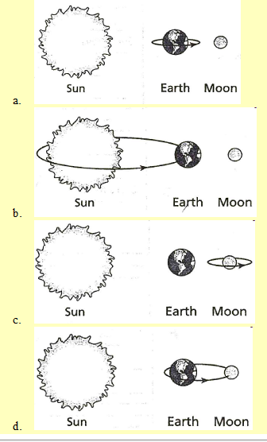Earth ROTATES on its axis to get “DAY and NIGHT”

Earth REVOLVES around the sun to get a YEAR and the SEASONS (WITH the TILT of the Earth)

Moon ROTATES at the same speed as it REVOLVES

Moon REVOLVES around the Earth to get Moon PHASES

New Moon, Waxing Crescent, Waxing FIRST Quarter, Waxing Gibbous, Full Moon, Waning Gibbous, Waning THIRD Quarter, Waning Crescent

THE MOON Revolves COUNTERCLOCKWISE

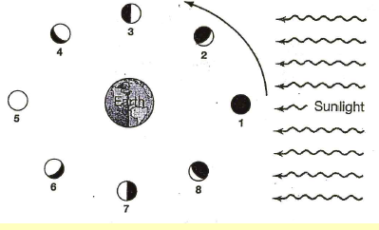

**Moon Phases**

**Seasons**

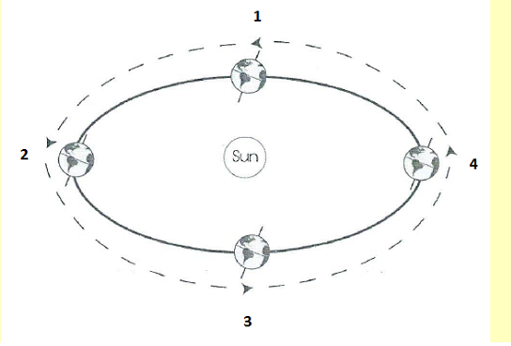

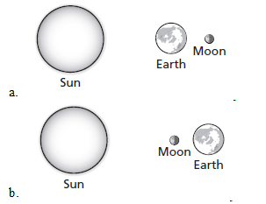**Lunar Eclipse**

**Solar and Lunar Eclipses**

**Solar Eclipse**

**Tide - Highest Ranges**

**Spring Tide**

**Straight Line**

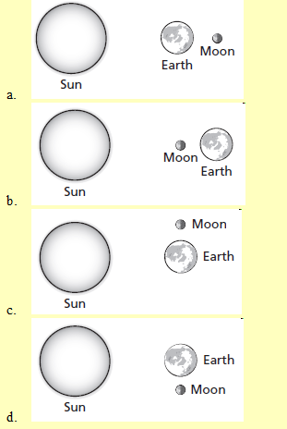

**Tide – Lowest Range**

**Neap Tide ----**

**Right Angles**

1. Wherever the moon faces is a high tide and the opposite side
2. When the moon, sun, and earth make a **S**TRAIGHT LINE, it creates a **S**PRING TIDE
3. When the moon, sun, and earth make a **RIGHT** ANGLE, it creates a **NEAP** TIDE

**Components of the Universe**

1. Eight Major planets make an elliptical orbit (revolution) around the sun with sun in the center of their orbits.
   1. Mercury, Venus, Earth, Mars, Jupiter, Saturn, Uranus, and Neptune
   2. Pluto is now a Dwarf Planet and is on the edge of our Solar System
2. The **Asteroid Belt** is full of **rocky** objects that vary in size and mostly orbit between Mars and Jupiter
3. **Comets** are a large **mass of rock, gas, and dust**. Comes **orbit very closely to the sun** and **then orbit outside of our Solar System** in the **Kuiper Belt** and **Oort Cloud.**
   1. Hailey Comet is the most famous comet that orbits the sun every 76 years
   2. Comets have a head/nucleus and a dust tail that extends millions of kilometers.
   3. As a **Comet orbits near the sun**, it will **develop a second tail**, call the ion tail that will point away from the sun is made of gas

**Comet**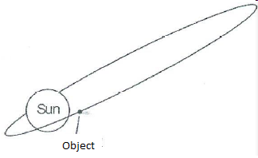

1. **Meteorite** = Meteors that **reach the surface** of the earth
2. **Meteoroids** = Meteors that are **in space**
3. **Meteors** = Are Meteoroids that travel and **burn through the Earth’s Atmosphere**
4. **Stars** = Are burning balls of gas (Hydrogen and Helium)
   1. Stars have a life cycle: Born, Live, and Die
   2. Our Sun is a middle aged star
   3. **Many Stars together will form a Galaxy**
      1. There are 3 types of Galaxies
         1. **Elliptical = Old** stars - round in shape
         2. **Spiral = Middle Age** Stars = looks like a Pinwheel
            1. We live in a Spiral Galaxy called the Milky Way
         3. **Irregula**r = No defining Shape = **Young** Stars
5. **Black Holes** are areas in space with **huge gravitational field** that pulls anything close including light into its center
6. Once a Black Hole is full, it will shoot out light energy and become a Quasar
7. The **Order of the component sizes** from the smallest to the largest:
   1. **Stars, Solar System, Galaxies, Universe**

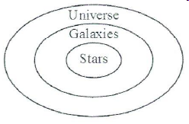

**Layers of the Atmosphere**

1. Layers in order from Top Layer to the bottom layer:

5. **Exosphere** = Thinnest Layer – Satellites Orbit in this layer – gases may escape

4. **Thermosphere** = Hottest layer – Contains the Ionosphere that show the Auroras and Radio Waves Bounce off

3. **Mesosphere** = **middle l**ayer where meteors burn because of friction- Coldest layer

2. **Stratosphere** = The second layer that contains the **Ozone** layer that protects the earth from UV rays

1. **Troposphere** = The Bottom layer that **WE LIVE** in and **WEATHER occurs** (most planes Fly)

**\*\*\*\*\*\*\*\*\*\*\*\*\*\*The Screaming Monster Terrorized Everyone\*\*\*\*\*\*\*\*\*\*\*\*\*\*\*\*\***

**3 Ways that Heat is transferred in the Atmosphere**

1. **Conduction** = transfer through **direct contact**
2. **Convection** = the transfer **through AIR or WATER**
3. **Radiation** = the transfer through **SPACE** from the sun (or microwave)

**Temperature**

1. **Temperature is the movement of (heat) particles** in the air, water, substances, and space
2. There are 3 scales used to measure temperature
   1. **Fahrenheit** = used in the US
      1. 32 ⁰F = Freezing
      2. 212⁰F = Boiling
      3. **72⁰F = Room Temperature**
   2. **Celsius** = a part of the metric system and used by scientists all around the world
      1. 0⁰ C = Freezing
      2. 100 ⁰C = Boiling
      3. **22⁰C = Room Temperature**
         1. **Thirty is Hot**
         2. **Twenty is Nice**
         3. **Ten is Cool**
         4. **Zero is Ice**
   3. **Kelvins** is used to measure extremely hot temperatures (Stars) or extremely cold temperatures (Deep Space)

**If the AIR MOVES – it is WIND -- Usually due to CONVECTION**

**Winds**

1. Winds are **created by the UNEVEN HEATING of the EARTH by the SUN**
   1. Types of winds (Named for the direction they come from = DUE TO THE COROLIS EFFECT)
      1. Prevailing --- **Polar Easterlies**
      2. Prevailing --- **Westerlies (Has the most affect on US weather patterns)**
      3. Prevailing --- **Trade Winds**
      4. **Doldrums** = NO or LITTLE Wind
      5. **JET STREAM** – Strong winds the ZIG ZAG Horizontally and affect the WEATHER in the US by MOVING the PREVAILING WIND PATTERNS

The

**Breezes**

1. **Sea Breeze = Occurs during the DAY**

1. Land Heats faster than the Sea
2. Hot air rises above the land, cool air from **the sea moves under the hot rising air**

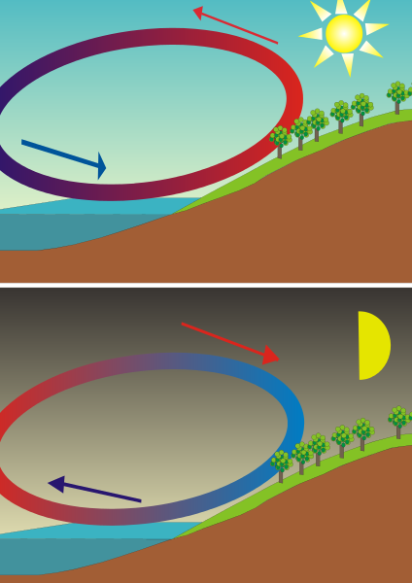

**2. Land Breeze** = **Occurs during the NIGHT**

1. Sea is warm from heating all day –
2. Heat will radiate off the sea and the cool air from the Land moves under the warm rising air



**Ocean Currents**

1. The Oceans have warm and cold currents due to the UNEVEN HEATING Of the EARTH’S SURFACE
   1. **Warm currents** Rise from the EQUATOR AND Move towards the POLES
      1. Example of Warm Current – **THE GULF STREAM**
   2. **Cold currents** sink at the POLES AND Move Towards the EQUATOR
      1. Example of Cold Current – **THE CALIFORNIA CURRENT / PERU-HUMBOLDT**
      2. **COLD Water is more DENSE** than Warm Water due to Cold Temperature and SALINITY (SALT)
2. The Coriolis Effect also affects the direction **SURFACE CURRENTS** travel, since surface currents are **carried AND Caused by the WIND**

**CLOUDS**

1. Clouds are form as WATER VAPOR CONDENSES on dust particles in the air
2. There are 3 Main Types of Clouds
   1. **STRATUS** = Low Clouds, look like a blanket
      1. **Nimbostratus** – Low gray to dark looking clouds
      2. Responsible for rain, snow, freezing rain, or sleet over a period of time
   2. **CUMULUS =** Middle level clouds that look like cotton balls – Puffy, fluffy, white in color
      1. Responsible for Fair Weather
      2. **CUMULONIMBUS** – Middle level, high stacking clouds, dark in color
         1. Responsible for **Thunderstorms, Hail, and Tornadoes**
   3. **Cirrus** – HIGH level clouds, look like light paint strokes, wispy, white clouds, made of ice crystals
      1. Responsible for **FAIR Weather**

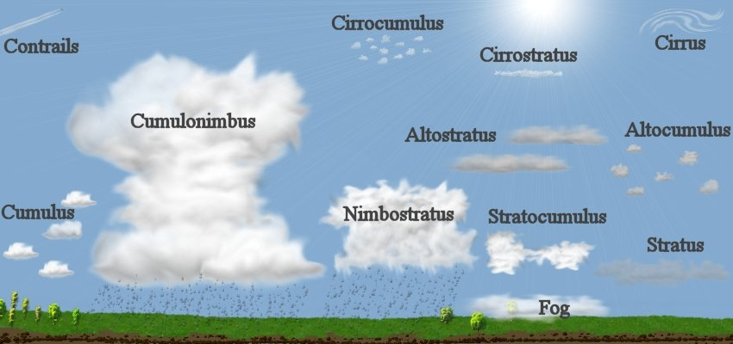

**To Predict the Weather:**

* + - 1. LOOK at **Type of CLOUDS**
         1. Cumulus – Fair
         2. Cumulonimbus – Thunderstorms, Hail, Winds
         3. Cirrus – Fair
         4. Stratus/White – Fair
         5. Nimbostratus – Rain, Sleet, Snow, Freezing Rain
      2. **Temperature –** IF above 32⁰ F / 0⁰ C --- THEN Rain

IF BELOW 32⁰ F / 0⁰ C --- THEN Snow, Freezing Rain or Sleet

* + - 1. **Air Pressure** 
         1. **Higher** number (to 31 in or 1050 mb) **GOOD** WEATHER
         2. **Lower** Number (to 28 in or 950 mb) **Rainy to SNOWY** Weather
         3. Pressure **DROPS QUICKLY=== STORM!!**
      2. **WIND** – MOST WEATHER IN THE US TRAVELS
         1. **WEST TO EAST** (Due to prevailing Westerlies)
         2. **WIND DETERMINES HOW FAST WEATHER MOVES**
      3. **PRESSURE SYSTEMS:**
         1. **HIGH (COLD)** Moves to  **LOW (WARM)**
      4. **Humidity** 
         1. **Closer to 100% - Rain/Snow**
         2. **Closer to 0% - Fair Weather**
      5. **DEWPOINT**
         1. Temperature where the air will condense –

Frost, Dew, Clouds, Precipitation

e **Energy** is the ability to DO Work or Move an Object

**Energy**

**Kinetic Energy** = Energy of movement / Motion

**Potential Energy** = Energy at rest or position

**Gravitational Potential** **(GPE)** = Potential energy Due to HEIGHT

**Elastic Potential** = Potential energy Due to an object being STRETCHED or COMPRESSED

**Chemical Potential** = Potential energy Due to chemical BONDS

**AS Kinetic Energy goes up = Potential Energy goes down**

**AND AS Potential Energy goes up Kinetic Energy goes down** 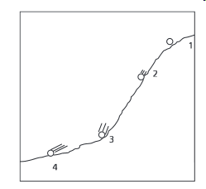

**Greatest GPE at position 1**

**Greatest Kinetic at position 4 (The Lines from the ball tell that it is still moving!)**

**FORMS OF ENERGY: (Mrs Chen)**

**Mechanical = all kinetic & potential used to move an object or do a job**

**Radiant = Light**

**Sound = Energy of vibrations**

**Chemical = Energy of Bonds (Food, Fossil Fuels, Batteries, & Living things)**

**Heat = Energy of movement of atoms**

**Electrical = Energy of moving electrons**

**Nuclear = Energy released by fission (splitting one nucleus) and fusion (smashing two nuclei together)**

**Law of Conservation of Energy:**

**ENERGY IS NOT CREATED OR DESTROYED – IT ONLY CHANGES FORM**

**Energy Transformations**

**r**

**NOT CREATED NOT DESTROYED**

**ONLY CHANGES FORM!!!!!**

**Examples: Flashlight = Chemical Electrical Radiant (light) AND Thermal (Heat)**

**Campfire = Chemical Light Thermal (Heat)**

**Roller Coaster = GPE Kinetic (Mechanical)**

**Electricity**

**Current Electricity = The Flow of electrons in a conductor**

**Two types of Current:**

**AC = Alternating current from a generator (Found in all buildings)**

**DC = Direct Current from a BATTERY**

**Circuit – The Path the electricity flows through (Copper Wire or other metal objects)**

**Conductor – ALLOW Electrons to flow through – Most METALS**

**Insulator – DOES NOT allow Electrons to flow through - Glass, Plastic, rubber, cloth**

**Two Types of CIRCUITS**

**Series = ONE PATH** 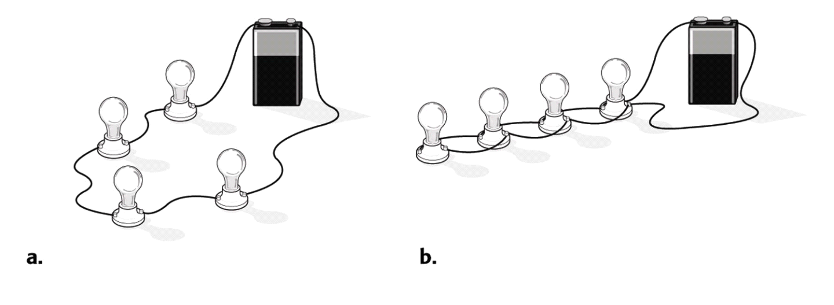

**Parallel = At Least TWO (2) PATHS **

**STATIC ELECTRICITY - The build of electrical charges (Positive or Negative) then how it discharges to balance the charges on two surfaces.**

**Example – Lightning**

**Clothes out of a dryer (Static Cling)**

**Scuffing feet on a carpet and touching a door knob or someone else**

**Circuits - Open Circuit the path has a gap or open switch- Electricity will NOT flow**

**Closed Circuit – the path is complete or switch is closed – Electricity CAN Flow**

**Energy Transformations in a Circuit**

**Example:**

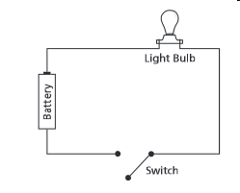**-**

Once the switch is closed – these are the transformations

1. Start with the Battery = **Chemical**
2. Turns into **Electrical**
3. Then **Light (Radiant)**
4. Finally **Heat/thermal**

**\*IN ALL ENERGY TRANSFORMATION – HEAT IS ONE OF THE FORMS IN THE TRANSFORMATIONS**

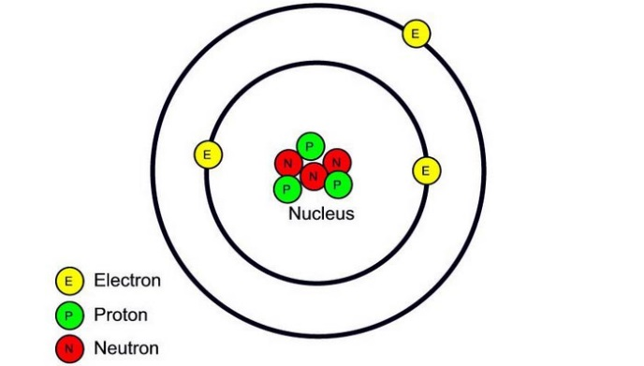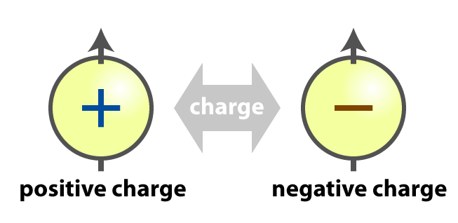

**Opposite** charges **ATTRACT** Each other

**Like** Charges **REPEL** each other

**\*\*\*\*THEREFORE – ELECTRONS (NEGATIVE) ARE ATTRACTED TO THE PROTON (POSITIVE)**