**Study Guide for Second Nine week Test**

**FOCUS ON ENERGY & ECOSYSTEMS!!!!**

**Scientific Method**

**1. Scientific Methods – are ways scientists follow steps to answer a question or solve a problem**

**2. Hypothesis – a possible explanation or guess to the question or problem**

**3. Controlled experiment – Tests on ONE factor at time – with a control (Does not get the change) to compare to**

**4. Scientific Method:**

**a. Make an observation to ask a Question**

**b. Make an Hypothesis**

**c. Do an experiment**

**d. Record and Analyze the Data**

**e. Make a Conclusion**

**f. Share your results**

Engineering Design Process

**1. My RESULTS DEPENDS on What I CHANGE (independent variable)**

**2. Variable – any factor or part that can affect an experiment (examples: cup, fish, amount of water, ice)**

**3. Independent Variable – What “I” change in an experiment**

**4. Dependent Variable – The RESULT of what I change**

**5. Experimental Group – The Group That gets the CHANGE**

**6. Control – The group or part that DOES NOT get the change and used to compare to**

**7. Trial – Repeating the experiment, each time the experiment is done is called a trial**

**8. Engineering Design Process Steps**

**a. Ask (what is the problem or question)**

**b. Imagine (the answer to the problems or question)**

**c. Plan and create (draw a blueprint or design – the build the prototype)**

**d. Improve – What changes can you make**

**Technology**

**1. Assistive Technology – HELPS the organism (Glasses, canes, inhalers, walkers)**

**Permanently (laser eye surgery, insulin pumps, knee replacement, doorbell light for the deaf)**

**Conclusions**

**1. Must support or NOT Support the Hypothesis**

**2. A Valid conclusion is one that can be trusted**

**a. Experiment should be repeated many times with same results**

**b. The experiment should be repeated by others**

**Scientific Tools**

**1. Metric System**

**a. Kilo, Hecto, Deka { BASE UNIT (meter, liter, gram)}, Deci, Centi, Milli**

**b. King Henry Doesn’t Usually Drink Chocolate Milk**

**c. Celsius Temperatures:**

**i. Thirty is hot**

**Twenty is nice**

**Ten is cool**

**Zero is ICE!**

**2. Tools**

**a. Beaker – to measure or mix liquids or pourable solids**

**b. Gradated cylinders – to measure liquids**

**c. Balance scale – to compare two measures or compare one item to a given weight**

**d. Meter stick – to measure length**

**e. Thermometer – to measure temperature**

**f. Microscope – to view TINY objects**

**g. Telescope – to view objects FAR AWAY**

**Temperature**

1. **Temperature is the movement of (heat) particles** in the air, water, substances, and space

2. There are 3 scales used to measure temperature

a. **Fahrenheit** = used in the US

i. 32 ⁰F = Freezing

ii. 212⁰F = Boiling

**iii. 72⁰F = Room Temperature**

b. **Celsius** = a part of the metric system and used by scientists all around the world

i. 0⁰ C = Freezing

ii. 100 ⁰C = Boiling

**iii. 22⁰C = Room Temperature**

**1. Thirty is Hot**

**2. Twenty is Nice**

**3. Ten is Cool**

**4. Zero is Ice**

c. **Kelvins** is used to measure extremely hot temperatures (Stars) or extremely cold temperatures (Deep Space)

**Energy**

**Energy** is the ability to DO Work or Move an Object

**Kinetic Energy** = Energy of movement / Motion

**Potential Energy** = Energy at rest or position

**Gravitational Potential (GPE)** = Potential energy Due to HEIGHT

**Elastic Potential** = Potential energy Due to an object being STRETCHED or COMPRESSED

**Chemical Potential** = Potential energy Due to chemical BONDS



**Greatest GPE at position 1**

**Greatest Kinetic at position 4 (The Lines from the ball tell that it is still moving!)**

**As Kinetic Energy goes up = Potential Energy goes down**

**AND As Potential Energy goes up Kinetic Energy goes down**

**FORMS OF ENERGY: (Mrs Chen)**

**Mechanical = all kinetic & potential used to move an object or do a job**

**Radiant = Light**

**Sound = Energy of vibrations**

**Chemical = Energy of Bonds (Food, Fossil Fuels, Batteries, & Living things)**

**Heat = Energy of movement of atoms**

**Electrical = Energy of moving electrons**

**Nuclear = Energy released by fission (splitting one nucleus) and fusion (smashing two nuclei together)**

**Law of Conservation of Energy:**

**ENERGY IS NOT CREATED OR DESTROYED – IT ONLY CHANGES FORM**

**Examples: Flashlight = Chemical Electrical Radiant (light) AND Thermal (Heat)**

**Campfire = Chemical Light Thermal (Heat)**

**Roller Coaster = GPE Kinetic (Mechanical)**

**Electricity**

**Current Electricity = The Flow of electrons in a conductor**

**Two types of Current:**

**AC = Alternating current from a generator (Found in all buildings)**

**DC = Direct Current from a BATTERY**

**Circuit – The Path the electricity flows through (Copper Wire or other metal objects)**

**Conductor – ALLOW Electrons to flow through – Most METALS**

**Insulator – DOES NOT allow Electrons to flow through - Glass, Plastic, rubber, cloth**

**Two Types of CIRCUITS**

**Series = ONE PATH **

**Parallel = At Least TWO (2) PATHS **

**STATIC ELECTRICITY - The build of electrical charges (Positive or Negative) then how it discharges to balance the charges on two surfaces.**

**Example – Lightning**

**Clothes out of a dryer (Static Cling)**

**Scuffing feet on a carpet and touching a door knob or someone else**

**Circuits - Open Circuit the path has a gap or open switch- Electricity will NOT flow**

**Closed Circuit – the path is complete or switch is closed – Electricity CAN Flow**

**Energy Transformations in a Circuit**

**Example:**



Once the switch is closed – these are the transformations

**1.** Start with the Battery = **Chemical**

2. Turns into **Electrical**

3. Then **Light (Radiant)**

4. Finally **Heat/thermal**

**\*IN ALL ENERGY TRANSFORMATION – HEAT IS ONE OF THE FORMS IN THE TRANSFORMATIO**

 

**Opposite** charges **ATTRACT** Each other

**Like** Charges **REPEL** each other

**\*\*\*\*THEREFORE – ELECTRONS (NEGATIVE) ARE ATTRACTED TO THE PROTON (POSITIVE)**

**Interactions of Living Things**

1. **Biotic – LIVING Things**
2. **Abiotic – NON – LIVING Things**
3. **Limiting Factors** – **resource that is SO SCARCE that it limits the size of the Population**
   1. **(Examples:** food, water, living space…)
4. **Carry Capacity – the largest population that an environment can support**
5. **Producers – PLANTS – make their own food through PHOTOSYNTHESIS**
6. **Consumers – EAT plants or other consumers**
   1. **Primary Consumers – Eat PLANTS**
   2. **Secondary Consumers – Eat animals that EAT Plants**
   3. **Third Consumers – Usually top of the food chain**
   4. **Fourth Consumers – Usually decomposers**

**Energy Flow**

1. **The ARROWS point to the one doing the EATING!**
2. **FOOD CHAIN - ONE line only**
3. **FOOD WEB – many food chains together – looks like a web**
4. **Energy Pyramid – a model for how the energy spreads through an ecosystem**

**Fourth level**-Decomposers and Scavengers

**Third level Consumers**- Omnivores

**Second Level Consumers** – Carnivores

**First Level Consumers** – Herbivores

**Producers** - Plants

**Levels of the Environment**

1. **Organism – only ONE**
2. **Population – Two or more of the same animal/plant**
3. **Community – many populations in a given area**
4. **Ecosystem – a community and its NON-LIVING (Abiotic) parts**
5. **Biosphere – All the ecosystems of the earth**

**Adaptations**

1. **Camouflage**
2. **Warning Coloration**
3. **Teeth adaptations**
4. **Feet adaptations**
5. **Beak adaptations**
6. **Behavioral adaptations**
7. **Communication adaptations**
   1. **Structure – A physical change**
   2. **Behavioral – behavior that communicates**
      1. **Tactile (Touching) ex. Grooming each other**
      2. **Auditory ex. Echolocation, hissing, alarm calls, signal calls, signature whistles**
      3. **Playing dead, use of odors, hunt & chase, building nests, standing guard**

**Symbiosis KNOW EXAMPLES OF THESE!!!!**

1. **Mutualism – BOTH Benefit/HELPED**
2. **Commensalism – ONE Benefits – other is UNAFFECTED**
3. **Parasitism – ONE Benefits – other is HURT**
4. **Predator – Hunts and Eats**
5. **Prey – Being Hunted and is Eaten**
6. **Invasive Species – a species that is not native to an area and will take over disrupting an ecosystem (ex. Kudzu, Tree of Heaven, Fire Ants, Africanized Bees, Zebra Mussels)**

**Biomes**

1. **Tundra – COLD Desert – at the poles or tops of mountains**
2. **Taiga – Coniferous Forest – Evergreen Trees – Right below the Tundra at the poles**
3. **Temperate Deciduous Forest – SEASONS – Leaves fall in the FALL- makes very RICH Soil**
4. **Rainforest – At the EQUATOR – NO Seasons – always summer – POOR Soil due to no leaves falling in fall**
5. **Desert – Less than 25 cm or 10 inches of rain- Extreme temperatures , hot = day, cold = night, poor soil, animals adapt to live there**
6. **Grasslands – Grasses very few trees, found in all over the earth, RICH SOIL**
   1. **Prairie – North America**
   2. **Steepe – Asia**
   3. **Savannas & Velt – Africa**
   4. **Pampas – South America**
7. **Freshwater Biomes – little or no salt content, includes flowing and standing water**
   1. **Flowing freshwater – rivers or streams**
   2. **Standing freshwater – ponds or lakes**
      1. **Wetlands - home to many plants and animals (also called a swamp)**
8. **Saltwater Biomes**
   1. **Coral Reefs – formed from dead skeletons of coral over a long period of time**
      1. **Home of a large DIVERSE of plants and animals (Nemo!)**
   2. **Ocean – 4 zones**
      1. **Intertidal – contains the shoreline / coast (high and low tides)**
      2. **Neritic Zone – still receives sunlight, water still warm, plants and marine animals**
      3. **Oceanic Zone – Sea floor drops sharply, plankton near surface**
      4. **Benthic Zone- Deepest part of the ocean – no sunlight at the ocean floor, some animals get energy from thermal vents**
   3. **Estuaries- Where FRESHWATER and SALT WATER Meet! - Contains most of OUR SEAFOOD, very rich in nutrients**

**3 Ways that Heat is transferred in the Atmosphere**

1. **Conduction** = transfer through **direct contact**
2. **Convection** = the transfer **through AIR or WATER**
3. **Radiation** = the transfer through **SPACE** from the sun (or microwave)

to 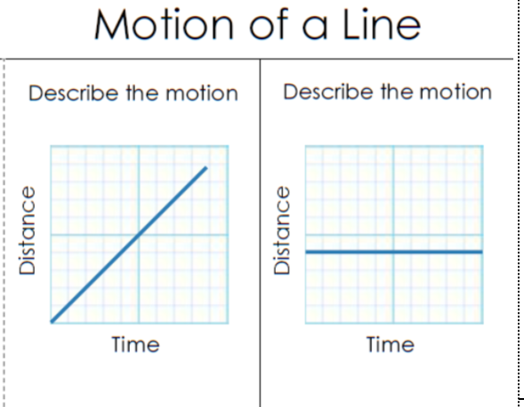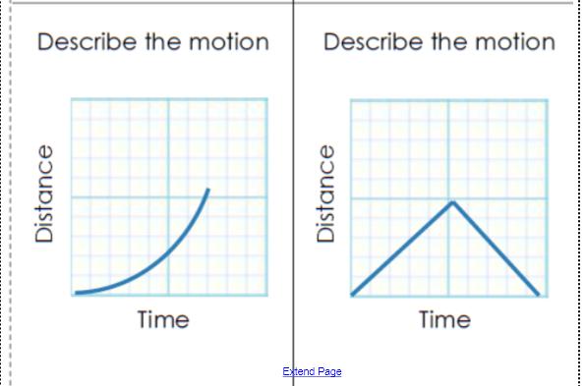

Constantly going up No Change Going up- not constant Goes up but returns

**Population changes over time:**

**Short Term impact – Ecosystem can recover back to equilibrium in your life time**

**Long Term impact – Ecosystem may take several generations to recover back to equilibrium**

**Human Impact:**

**1 Over Population 6 Building of Cities and Houses**

**2 Strip Mining 7 Over Hunting and/or poaching**

**3 Pollution 8 Over Fishing**

**4 Drilling for Oil 9 Physically changing an ecosystem**

**5 Deforestation 10 Man caused fires**

**Environmental Impact**

**1 Global Warming 7 Tsunamis**

**2 Hurricanes 8 Ice Age**

**3 Tornadoes 9 Fires by lightning**

**4 Flooding 10 Greenhouse Effect**

**5 Drought 11 Climate Change**

**6 Earthquakes 12 Volcanoes**

**Primary Succession – Starts with Bare Rock – Takes 1000s of years to restore ecosystem**

**Secondary Succession – Starts with Soil – Ecosystem recovers rapidly**