Key notes for MIDTERM Test
Scientific Method
- Scientific Methods – are ways scientists follow steps to answer a question or solve a problem
- Hypothesis – a possible explanation or guess to the question or problem
- Controlled experiment – Tests on ONE factor at time – with a control (Does not get the change) to compare to
- Scientific Method:
  - Make an observation to ask a Question
  - Make an Hypothesis
  - Do an experiment
  - Record and Analyze the Data
  - Make a Conclusion
  - Share your results
Engineering Design Process

- My RESULTS DEPENDS on What I CHANGE (independent variable)
- Variable – any factor or part that can affect an experiment ( examples: cup, fish, amount of water, ice)
- Independent Variable – What “I” change in an experiment
- Dependent Variable – The RESULT of what I change
- Experimental Group – The Group That gets the CHANGE
- Control – The group or part that DOES NOT get the change and used to compare to
- Trial – Repeating the experiment, each time the experiment is done is called a trial
- Engineering Design Process Steps
  - Ask (what is the problem or question)
  - Imagine (the answer to the problems or question)
  - Plan and create (draw a blueprint or design – the build the prototype)
  - Improve – What changes can you make
Technology

- Assistive Technology – HELPS the organism (Glasses, canes, inhalers, walkers)
- Adaptive Technology – CHANGES the organism Permanently or lifestyle change Permanently (laser eye surgery , insulin pumps, knee replacement, doorbell light for the deaf)
Conclusions

- Must support or NOT Support the Hypothesis
- A Valid conclusion is one that can be trusted
  - Experiment should be repeated many times with same results
  - The experiment should be repeated by others
Bias and Error
- Error can happen when:
  - Wrong measurements
  - Using the wrong scientific tools
  - Changing the conditions (like the temperature in the room of the experiment)
- Bias is an expectation that leads to a particular conclusion
  - May be something in the unconscious (back of mind)
  - Person may not want to be wrong
  - Misrepresentation of Data
  - Opinion
  - Past experiences
Scientific Tools

- Metric System
  - Kilo, Hecto, Deka { BASE UNIT (meter, liter, gram)}, Deci, Centi, Milli
  - King Henry Doesn’t Usually Drink Chocolate Milk
  - Celsius Temperatures:
    - Thirty is hot
Twenty is nice
Ten is cool
Zero is ICE!
- Tools
  - Beaker – to measure or mix liquids or pourable solids
  - Gradated cylinders – to measure liquids
  - Balance scale – to compare two measures or compare one item to a given weight
  - Meter stick – to measure length
  - Thermometer – to measure temperature
  - Microscope – to view TINY objects
  - Telescope – to view objects FAR AWAY
Interactions of Living Things

- Biotic – LIVING Things
- Abiotic – NON – LIVING Things
- Limiting Factors – resource that is SO SCARCE that it limits the size of the Population
  - (Examples: food, water, living space…)
- Carry Capacity – the largest population that an environment can support
- Producers – PLANTS – make their own food through PHOTOSYNTHESIS
- Consumers – EAT plants or other consumers
  - Primary Consumers – Eat PLANTS
  - Secondary Consumers – Eat animals that EAT Plants
  - Third Consumers – Usually top of the food chain
  - Fourth Consumers – Usually decomposers
Energy Flow

- The ARROWS point to the one doing the EATING!
- FOOD CHAIN - ONE line only
- FOOD WEB – many food chains together – looks like a web
- Energy Pyramid – a model for how the energy spreads through an ecosystem
Fourth level-Decomposers and Scavengers
Third level Consumers- Omnivores
Second Level Consumers – Carnivores
First Level Consumers – Herbivores
Producers - Plants

Levels of the Environment

- Organism – only ONE
- Population – Two or more of the same animal/plant
- Community – many populations in a given area
- Ecosystem – a community and its NON-LIVING (Abiotic) parts
- Biosphere – All the ecosystems of the earth

Adaptations

- Camouflage
- Warning Coloration
- Teeth adaptations
- Feet adaptations
- Beak adaptations
- Behavioral adaptations
KNOW EXAMPLES OF THESE!!!!
Symbiosis

- Mutualism – BOTH Benefit/HELPED
- Commensalism – ONE Benefits – other is UNAFFECTED
- Parasitism – ONE Benefits – other is HURT

- Predator – Hunts and Eats
- Prey – Being Hunted and is Eaten
Cycles

- Water Cycle
  - Evaporation – Turn liquid water to a GAS
  - Condensation – Turns Gas back into a LIQUID – Makes CLOUDS
  - Precipitation – Clouds can NOT hold any more water – it falls as rain , snow, sleet, or hail
  - Transpiration – The waste of Plants that releases WATER into the Air
- Carbon Cycle (ALL living things contain carbon and need carbon – some nonliving things also are made of carbon)
  - Carbon is released for plants to use by:
    - Respiration – the breathing in of oxygen by animals and used to break down sugar and exhaling – CARBON DIOXIDE
    - Combustion – the burning of things that releases CARBON
    - Decomposition – Decomposers breaking down dead plants and animals and releasing CARBON in the soil
  - Animals and HUMANS get the carbon they need by EATING PLANTS or animals that have eaten plants
- Nitrogen Cycle – ALL living things need nitrogen but can NOT use Nitrogen GAS
  - PLANTS need nitrogen FIXED (3 ways to do)
    - Lightning will FIX Nitrogen
    - Bacteria will FIX Nitrogen
    - Decomposition will FIX Nitrogen
  - Animals and HUMANS get the Nitrogen they need by EATING PLANTS or animals that have eaten plants
Biomes

- Tundra – COLD Desert – at the poles or tops of mountains
- Taiga – Coniferous Forest – Evergreen Trees – Right below the Tundra at the poles
- Temperate Deciduous Forest – SEASONS – Leaves fall in the FALL- makes very RICH Soil
- Rainforest – At the EQUATOR – NO Seasons – always summer – POOR Soil due to no leaves falling in fall
- Desert – Less than 25 cm or 10 inches of rain- Extreme temperatures , hot = day, cold = night, poor soil, animals adapt to live there
- Grasslands – Grasses very few trees, found in all over the earth, RICH SOIL
  - Prairie – North America
  - Steepe – Asia
  - Savannas – Africa
  - Pampas – South America
- Freshwater Biomes – little or no salt content, includes flowing and standing water
  - Flowing freshwater – rivers or streams
  - Standing freshwater – ponds or lakes
    - Wetlands - home to many plants and animals (also called a swamp)
- Saltwater Biomes
  - Coral Reefs – formed from dead skeletons of coral over a long period of time
    - Home of a large DIVERSE of plants and animals (Nemo!)
  - Ocean – 4 zones
    - Intertidal – contains the shoreline / coast (high and low tides)
    - Neritic Zone – still receives sunlight, water still warm, plants and marine animals
    - Oceanic Zone – Sea floor drops sharply, plankton near surface
    - Benthic Zone- Deepest part of the ocean – no sunlight at the ocean floor, some animals get energy from thermal vents
  - Estuaries- Where FRESHWATER and SALT WATER Meet! - Contains most of OUR SEAFOOD, very rich in nutrients
Movements to make a Day, Lunar Cycle, & Year

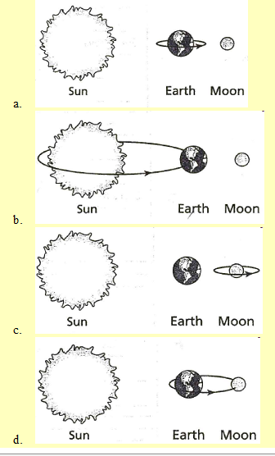
Earth ROTATES on its axis to get “DAY and NIGHT”

Earth REVOLVES around the sun to get a YEAR and the SEASONS (WITH the TILT of the Earth)

Moon ROTATES at the same speed as it REVOLVES

Moon REVOLVES around the Earth to get Moon PHASES

New Moon, Waxing Crescent, Waxing FIRST Quarter, Waxing Gibbous, Full Moon, Waning Gibbous, Waning THIRD Quarter, Waning Crescent
THE MOON Revolves COUNTERCLOCKWISE

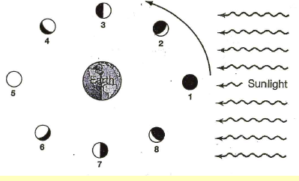
Moon Phases

Seasons
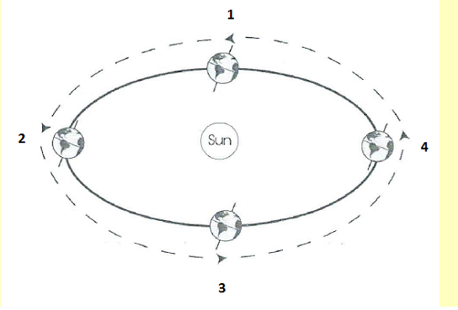
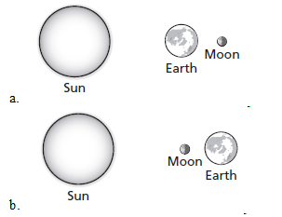
Lunar Eclipse
Solar and Lunar Eclipses

Solar Eclipse

Tide (High / Low)
Spring & Neap
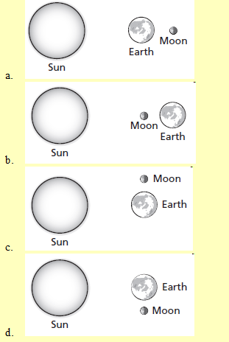

- Wherever the moon faces is a high tide and the opposite side
- When the moon, sun, and earth make a STRAIGHT LINE, it creates a SPRING TIDE
- When the moon, sun, and earth make a RIGHT ANGLE, it creates a NEAP TIDE
Components of the Universe

- Eight Major planets make an elliptical orbit (revolution) around the sun with sun in the center of their orbits.
  - Mercury, Venus, Earth, Mars, Jupiter, Saturn, Uranus, and Neptune
  - Pluto is now a Dwarf Planet and is on the edge of our Solar System
- The Asteroid Belt is full of rocky objects that vary in size and mostly orbit between Mars and Jupiter
- Comets are a large mass of rock, gas, and dust. Comes orbit very closely to the sun and then orbit outside of our Solar System in the Kuiper Belt and Oort Cloud.
  - Hailey Comet is the most famous comet that orbits the sun every 76 years
  - Comets have a head/nucleus and a dust tail that extends millions of kilometers.
  - As a Comet orbits near the sun, it will develop a second tail, call the ion tail that will point away from the sun is made of gas
Our 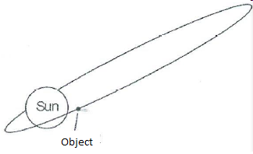

- Meteorite = Meteors that reach the surface of the earth
- Meteoroids = Meteors that are in space
- Meteors = Are Meteoroids that travel and burn through the Earth’s Atmosphere
- Stars = Are burning balls of gas (Hydrogen and Helium)
  - Stars have a life cycle: Born, Live, and Die
  - Our Sun is a middle aged star
  - Many Stars together will form a Galaxy
    - There are 3 types of Galaxies
      - Elliptical = Old stars - round in shape
      - Spiral = Middle Age Stars = looks like a Pinwheel
        - We live in a Spiral Galaxy called the Milky Way
      - Irregular = No defining Shape = Young Stars
- Black Holes are areas in space with huge gravitational field that pulls anything close including light into its center
- Once a Black Hole is full, it will shoot out light energy and become a Quasar
- The Order of the component sizes from the smallest to the largest:
  - Stars, Solar System, Galaxies, Universe

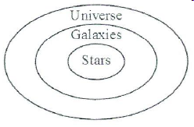

Layers of the Atmosphere

- Layers in order from Top Layer to the bottom layer:
  - 5. Exosphere = Thinnest Layer – Satellites Orbit in this layer
  - 4. Thermosphere = Hottest layer – Contains the Ionosphere that show the Auroras and Radio Waves Bounce off
  - 3. Mesosphere = The middle layer where meteors burn because of friction
  - 2. Stratosphere = The second layer that contains the Ozone layer that protects the earth from UV rays
  - 1. Troposphere = The Bottom layer that WE LIVE in and WEATHER occurs (small planes Fly)
3 Ways that Heat is transferred in the Atmosphere

- Conduction = transfer through direct contact
- Convection = the transfer through AIR or WATER
- Radiation = the transfer through SPACE from the sun (or microwave)
Temperature

- Temperature is the movement of particles in the air, water, substances, and space
- There are 3 scales used to measure temperature
  - Fahrenheit = used in the US
    - 32 ⁰F = Freezing
    - 212⁰F = Boiling
    - 72⁰F = Room Temperature
  - Celsius = a part of the metric system and used by scientists all around the world
    - 0⁰ C = Freezing
    - 100 ⁰C = Boiling
    - 22⁰C = Room Temperature
      - Thirty is Hot
      - Twenty is Nice
      - Ten is Cool
      - Zero is Ice

Winds
- Winds are created by the UNEVEN HEATING of the EARTH by the SUN
  - Types of winds (Named for the direction they come from = DUE TO THE COROLIS EFFECT)
    - Polar Easterlies
    - Westerlies
    - Trade Winds
    - Doldrums = NO or LITTLE Wind
    - JET STREAM – Strong winds the ZIG ZAG Horizontally and affect the WEATHER in the US
The
Breezes

1. Sea Breeze = Occurs during the DAY
- Land Heats faster than the Sea
- Hot air rises above the land, cool air from the sea moves under the hot rising air
2. Land Breeze = Occurs during the NIGHT
- Sea is warm from heating all day – Heat will radiate off the sea and the cool air from the Land moves under the warm rising air
Ocean Currents

- The Oceans have warm and cold currents due to the UNEVEN HEATING Of the EARTH’S SURFACE
  - Warm currents Rise from the EQUATOR AND Move towards the POLES
    - Example of Warm Current – THE GULF STREAM
  - Cold currents sink at the POLES AND Move Towards the EQUATOR
    - Example of Cold Current – THE CALIFORNIA CURRENT
    - COLD Water is more DENSE than Warm Water due to Cold Temperature and SALINITY (SALT)
- The Coriolis Effect also affects the direction SURFACE CURRENTS travel, since surface currents are carried by WND
CLOUDS

- Clouds are form as WATER VAPOR CONDENSES on dust particles in the air
- There are 3 Main Types of Clouds
  - STRATUS = Low gray Clouds, look like a blanket
    - Responsible for rain, snow, or sleet over a period of time
  - CUMULUS = Middle level clouds that look like cotton balls – Puffy, fluffy, white in color
    - Responsible for Fair Weather
    - CUMULONIMBUS – Middle level, stacking clouds, dark in color
      - Responsible for Thunderstorms, Hail, and Tornadoes
  - Cirrus – HIGH level clouds, look like light paint strokes, wispy, white clouds, made of ice crystals
    - Responsible for FAIR Weather

