**Study Guide for First Semester Exam**

**Scientific Method**

1. **Scientific Methods – are ways scientists follow steps to answer a question or solve a problem**



1. **Hypothesis – a possible explanation or guess to the question or problem**
2. **Controlled experiment – Tests on ONE factor at time – with a control (Does not get the change) to compare to**
3. **Scientific Method:**
   1. **Make an observation to ask a Question**
   2. **Make an Hypothesis**
   3. **Do an experiment**
   4. **Record and Analyze the Data**
   5. **Make a Conclusion**
   6. **Share your results**

Engineering Design Process

1. **My RESULTS DEPENDS on What I CHANGE (independent variable)**
2. **Variable – any factor or part that can affect an experiment ( examples: cup, fish, amount of water, ice)**
3. **Independent Variable – What “I” change in an experiment**
4. **Dependent Variable – The RESULT of what I change**
5. **Experimental Group – The Group That gets the CHANGE**
6. **Control – The group or part that DOES NOT get the change and used to compare to**
7. **Trial – Repeating the experiment, each time the experiment is done is called a trial**
8. **Engineering Design Process Steps**
   1. **Ask (what is the problem or question)**
   2. **Imagine (the answer to the problems or question)**
   3. **Plan and create (draw a blueprint or design – the build the prototype)**
   4. **Improve – What changes can you make**

**Technology**

1. **Assistive Technology – HELPS the organism (Glasses, canes, inhalers, walkers)**
2. **Adaptive Technology – CHANGES the organism Permanently or lifestyle change Permanently (laser eye surgery , insulin pumps, knee replacement, doorbell light for the deaf)**

**Conclusions**

1. **Must support or NOT Support the Hypothesis**
2. **A Valid conclusion is one that can be trusted**
   1. **Experiment should be repeated many times with same results**
   2. **The experiment should be repeated by others**

**Bias and Error**

1. **Error can happen when:**
   1. **Wrong measurements**
   2. **Using the wrong scientific tools**
   3. **Changing the conditions (like the temperature in the room of the experiment)**
2. **Bias is an expectation that leads to a particular conclusion**
   1. **May be something in the unconscious (back of mind)**
   2. **Person may not want to be wrong**
   3. **Misrepresentation of Data**
   4. **Opinion**
   5. **Past experiences**

**Scientific Tools**

1. **Metric System**
   1. **Kilo, Hecto, Deka { BASE UNIT (meter, liter, gram)}, Deci, Centi, Milli**
   2. **King Henry Doesn’t Usually Drink Chocolate Milk**
   3. **Celsius Temperatures:** 
      1. **Thirty is hot**

**Twenty is nice**

**Ten is cool**

**Zero is ICE!**

1. **Tools**
   1. **Beaker – to measure or mix liquids or pourable solids**
   2. **Gradated cylinders – to measure liquids**
   3. **Balance scale – to compare two measures or compare one item to a given weight**
   4. **Meter stick – to measure length**
   5. **Thermometer – to measure temperature**
   6. **Microscope – to view TINY objects**
   7. **Telescope – to view objects FAR AWAY**

**Interactions of Living Things**

1. **Biotic – LIVING Things**
2. **Abiotic – NON – LIVING Things**
3. **Limiting Factors** – **resource that is SO SCARCE that it limits the size of the Population**
   1. **(Examples:** food, water, living space…)
4. **Carry Capacity – the largest population that an environment can support**
5. **Producers – PLANTS – make their own food through PHOTOSYNTHESIS**
6. **Consumers – EAT plants or other consumers**
   1. **Primary Consumers – Eat PLANTS**
   2. **Secondary Consumers – Eat animals that EAT Plants**
   3. **Third Consumers – Usually top of the food chain**
   4. **Fourth Consumers – Usually decomposers**

**Energy Flow**

1. **The ARROWS point to the one doing the EATING!**
2. **FOOD CHAIN - ONE line only**
3. **FOOD WEB – many food chains together – looks like a web**
4. **Energy Pyramid – a model for how the energy spreads through an ecosystem**

**Fourth level**-Decomposers and Scavengers

**Third level Consumers**- Omnivores

**Second Level Consumers** – Carnivores

**First Level Consumers** – Herbivores

**Producers** - Plants

**Levels of the Environment**

1. **Organism – only ONE**
2. **Population – Two or more of the same animal/plant**
3. **Community – many populations in a given area**
4. **Ecosystem – a community and its NON-LIVING (Abiotic) parts**
5. **Biosphere – All the ecosystems of the earth**

**Adaptations**

1. **Camouflage**
2. **Warning Coloration**
3. **Teeth adaptations**
4. **Feet adaptations**
5. **Beak adaptations**
6. **Behavioral adaptations**

**KNOW EXAMPLES OF THESE!!!!**

**Symbiosis**

1. **Mutualism – BOTH Benefit/HELPED**
2. **Commensalism – ONE Benefits – other is UNAFFECTED**
3. **Parasitism – ONE Benefits – other is HURT**
4. **Predator – Hunts and Eats**
5. **Prey – Being Hunted and is Eaten**

**Cycles**

1. **Water Cycle**
   1. **Evaporation – Turn liquid water to a GAS**
   2. **Condensation – Turns Gas back into a LIQUID – Makes CLOUDS**
   3. **Precipitation – Clouds can NOT hold any more water – it falls as rain , snow, sleet, or hail**
   4. **Transpiration – The waste of Plants that releases WATER into the Air**
2. **Carbon Cycle (ALL living things contain carbon and need carbon – some nonliving things also are made of carbon)**
   1. **Carbon is released for plants to use by:**
      1. **Respiration – the breathing in of oxygen by animals and used to break down sugar and exhaling – CARBON DIOXIDE**
      2. **Combustion – the burning of things that releases CARBON**
      3. **Decomposition – Decomposers breaking down dead plants and animals and releasing CARBON in the soil**
   2. **Animals and HUMANS get the carbon they need by EATING PLANTS or animals that have eaten plants**
3. **Nitrogen Cycle – ALL living things need nitrogen but can NOT use Nitrogen GAS**
   1. **PLANTS need nitrogen FIXED (3 ways to do)**
      1. **Lightning will FIX Nitrogen**
      2. **Bacteria will FIX Nitrogen**
      3. **Decomposition will FIX Nitrogen**
   2. **Animals and HUMANS get the Nitrogen they need by EATING PLANTS or animals that have eaten plants**

**Biomes**

1. **Tundra – COLD Desert – at the poles or tops of mountains**
2. **Taiga – Coniferous Forest – Evergreen Trees – Right below the Tundra at the poles**
3. **Temperate Deciduous Forest – SEASONS – Leaves fall in the FALL- makes very RICH Soil**
4. **Rainforest – At the EQUATOR – NO Seasons – always summer – POOR Soil due to no leaves falling in fall**
5. **Desert – Less than 25 cm or 10 inches of rain- Extreme temperatures , hot = day, cold = night, poor soil, animals adapt to live there**
6. **Grasslands – Grasses very few trees, found in all over the earth, RICH SOIL**
   1. **Prairie – North America**
   2. **Steepe – Asia**
   3. **Savannas – Africa**
   4. **Pampas – South America**
7. **Freshwater Biomes – little or no salt content, includes flowing and standing water**
   1. **Flowing freshwater – rivers or streams**
   2. **Standing freshwater – ponds or lakes**
      1. **Wetlands - home to many plants and animals (also called a swamp)**
8. **Saltwater Biomes**
   1. **Coral Reefs – formed from dead skeletons of coral over a long period of time**
      1. **Home of a large DIVERSE of plants and animals (Nemo!)**
   2. **Ocean – 4 zones**
      1. **Intertidal – contains the shoreline / coast (high and low tides)**
      2. **Neritic Zone – still receives sunlight, water still warm, plants and marine animals**
      3. **Oceanic Zone – Sea floor drops sharply, plankton near surface**
      4. **Benthic Zone- Deepest part of the ocean – no sunlight at the ocean floor, some animals get energy from thermal vents**
   3. **Estuaries- Where FRESHWATER and SALT WATER Meet! - Contains most of OUR SEAFOOD, very rich in nutrients**

**Movements to make a Day, Lunar Cycle, & Year**

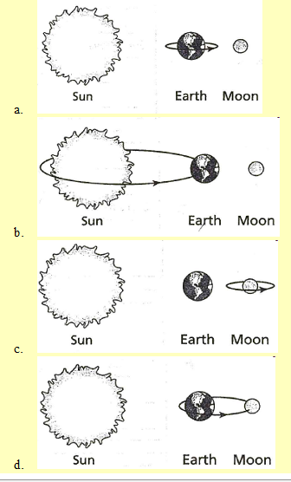Earth ROTATES on its axis to get “DAY and NIGHT”

Earth **REVOLVES** around the sun to get a **YEAR** (365 ¼ Days or 12 months) and the **SEASONS** (WITH the **TILT** of the Earth)

Moon **ROTATES** at the same speed as it REVOLVES

**Moon REVOLVES** around the Earth to get **Moon PHASES**

**Moon Phases Order:**

**New Moon**, Waxing Crescent, Waxing FIRST Quarter, Waxing Gibbous, Full Moon, Waning Gibbous, Waning THIRD Quarter, Waning Crescent

**THE MOON** Revolves **COUNTERCLOCKWISE** and goes around the earth about **12** times a year.

1. Find the sun
2. Place the moon between the sun and Earth – to get the NEW MOON
3. Go Counterclockwise to find the other Moon Phases

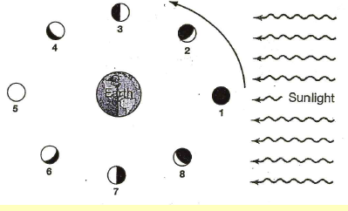

3rd Qtr.

1st Qtr.

New

Full

**Moon Phases**

**Seasons**

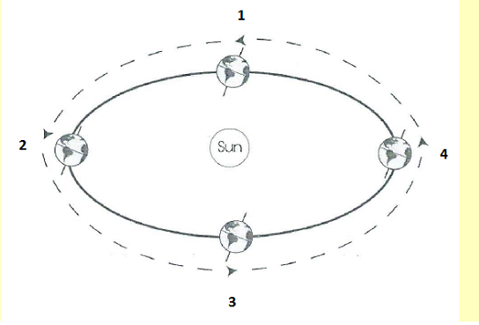

Summer

Summer

1. Find the direction of the Tilt
2. Find the ARMS first (Will be summer or Winter) – depending on which is closer the sun
3. Go counterclockwise to Find (Spring or Fall)

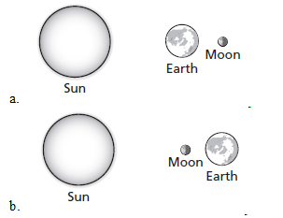

**Solar and Lunar Eclipses**

**Lunar Eclipses**

**Solar Eclipse**

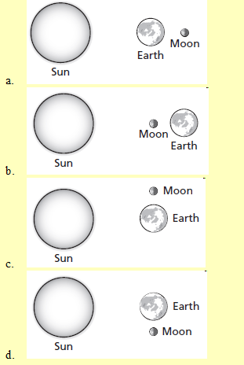

**Tide - Highest Ranges**

**Spring Tide**

**Straight Line**

**Tide – Lowest Range**

**Neap Tide ----**

**Right Angles**

1. Wherever the moon faces is a high tide and the opposite side
2. When the moon, sun, and earth make a **S**TRAIGHT LINE, it creates a **S**PRING TIDE
3. When the moon, sun, and earth make a **RIGHT** ANGLE, it creates a **NEAP** TIDE

**Components of the Universe**

1. Eight Major planets make an elliptical orbit (revolution) around the sun with sun in the center of their orbits.
   1. Mercury, Venus, Earth, Mars, Jupiter, Saturn, Uranus, and Neptune
   2. Pluto is now a Dwarf Planet and is on the edge of our Solar System
2. The **Asteroid Belt** is full of **rocky** objects that vary in size and mostly orbit between Mars and Jupiter
3. **Comets** are a large **mass of rock, gas, and dust**. Comes **orbit very closely to the sun** and **then orbit outside of our Solar System** in the **Kuiper Belt** and **Oort Cloud.**
   1. Hailey Comet is the most famous comet that orbits the sun every 76 years
   2. Comets have a head/nucleus and a dust tail that extends millions of kilometers.
   3. As a **Comet orbits near the sun**, it will **develop a second tail**, call the ion tail that will point away from the sun is made of gas

**Comet**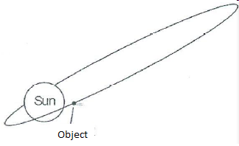

1. **Meteorite** = Meteors that **reach the surface** of the earth
2. **Meteoroids** = Meteors that are **in space**
3. **Meteors** = Are Meteoroids that travel and **burn through the Earth’s Atmosphere**
4. **Stars** = Are burning balls of gas (Hydrogen and Helium)
   1. Stars have a life cycle: Born, Live, and Die
   2. Our Sun is a middle aged star
   3. **Many Stars together will form a Galaxy**
      1. There are 3 types of Galaxies
         1. **Elliptical = Old** stars - round in shape
         2. **Spiral = Middle Age** Stars = looks like a Pinwheel
            1. We live in a Spiral Galaxy called the Milky Way
         3. **Irregula**r = No defining Shape = **Young** Stars
5. **Black Holes** are areas in space with **huge gravitational field** that pulls anything close including light into its center
6. Once a Black Hole is full, it will shoot out light energy and become a Quasar
7. The **Order of the component sizes** from the smallest to the largest:
   1. **Stars, Solar System, Galaxies, Universe**

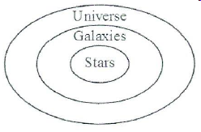

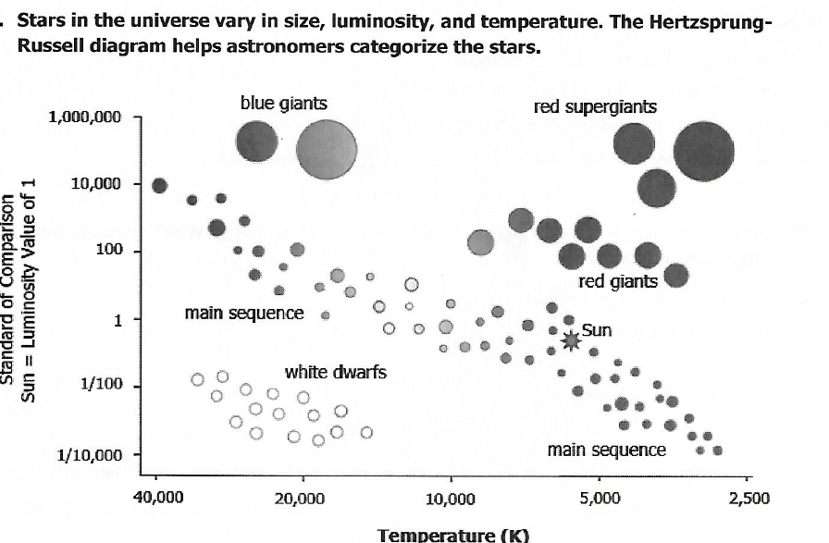

**Cooler Stars** 

**Bright Stars**

**Cooler Stars** 

**Hot Stars**

1. **Conduction** = transfer through **direct contact**

**3 Ways that Heat is transferred in the Atmosphere**

1. **Convection** = the transfer **through AIR or WATER**
2. **Radiation** = the transfer through **SPACE** from the sun (or microwave)

**If the AIR MOVES – it is WIND -- Usually due to CONVECTION**

**Winds**

1. Winds are **created by the UNEVEN HEATING of the EARTH by the SUN**
2. **HOT air RISES and COLD air SINKS (resulting is air moving = WIND)**

The

**Breezes**

1. **Sea Breeze = Occurs during the DAY**

1. Land Heats faster than the Sea
2. **Hot air rises above the land**, cool air from **the sea moves under the hot rising air**

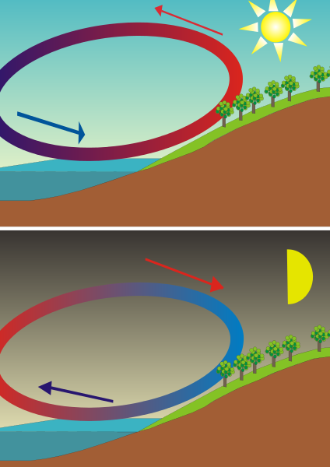

**2. Land Breeze** = **Occurs during the NIGHT**

1. Sea is warm from heating all day –
2. Heat will radiate off the sea and the **cool air from the Land moves under the warm** rising air



**Quick Rainstorm result from:**

1. **Hot air rising from near the ground**
2. **This hot air will cool as it rises higher in the air**
3. **Resulting in clouds forming**
4. **When the cloud cannot hold any more water/moisture, it will release the water in the cloud as rain, sleet, or snow (Precipitation)**

