Simple Circuits & the Transfer of Electrical Energy – Master Key
Parts of an Electrical Circuit
- Electrical energy is the energy of charged particles in matter.
- Electrical circuit is a path for the flow of electrical energy.
- Electrical circuits are set up so they can transform electrical energy into other forms of energy
- Electrical circuits have three main parts.
- A source of electrical energy, output device or a load, and connectors between the two.
Electrical Source
- Electrical source can be anything that supplies electricity.
Output Device
- An output device or load is anything that can use the electricity.
Connectors
- Connectors are usually wires.
Simple Circuit
- Electric current is the flow of electrical energy through a circuit.
Open Circuit
- An open circuit has a break in the flow of electricity
- A switch is the device that opens or closes a circuit.
- The switch is made of metal, like the wire, so an electric current can pass through it.
Closed Circuit
- A closed circuit is a complete path for the flow of electricity.
- The switch is closed, so the flow of electricity is not interrupted.

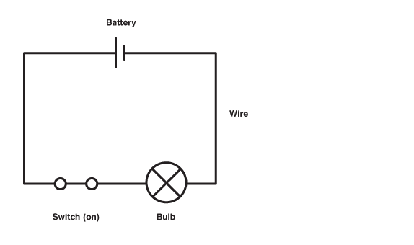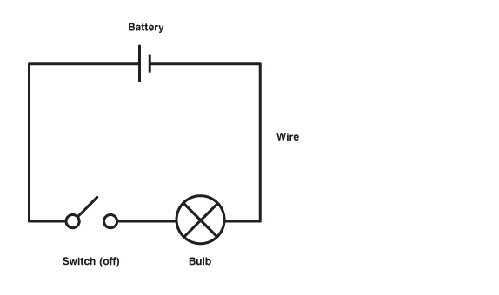
Conductors
- Electrical energy moves through some materials better than it does others.
- A conductor is a material that allows electric current to pass through it easily.
- Metals conduct electricity well.
- Examples are aluminum and copper.
Insulators
- An insulator is a material that does not let electric current pass through it easily.
- Most wires are wrapped in plastic or rubber.
- Other insulators are glass, wood, and air.
Series Circuit
- A series circuit is a circuit in which all parts are connected in a single loop. There is only one path for charges to follow, so the charges must flow through each part of the circuit.
Parallel Circuits
- A parallel circuit is a circuit in which loads (output devices) are connected side by side. Charges have more than one path on which they can travel.

