**Name: ________________________Tools of Science Class Period _____**

.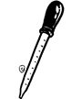  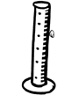

Tool:

Used For:

Tool:

Used For:

Tool:

Used For:

  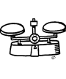

Tool:

Used For:

Tool:

Used For:

Tool:

Used For:

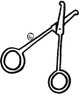 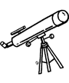 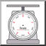

Tool:

Used For:

Tool:

Used For:

Tool:

Used For:

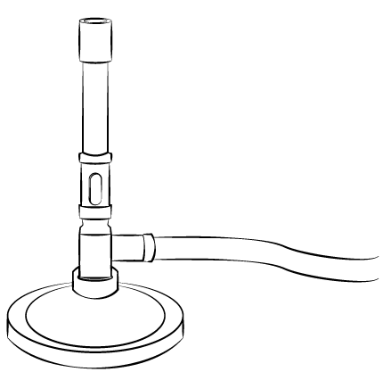  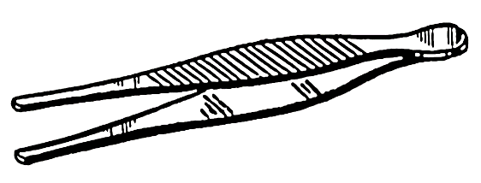

Tool:

Used For:

Tool:

Used For:

Tool:

Used For:

  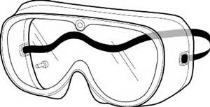

Tool:

Used For:

Tool:

Used For:

Tool:

Used For:

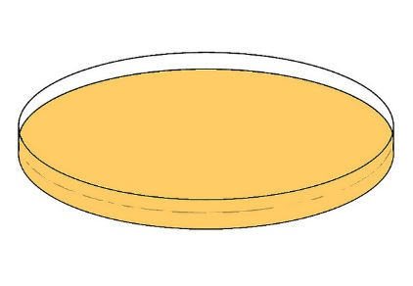 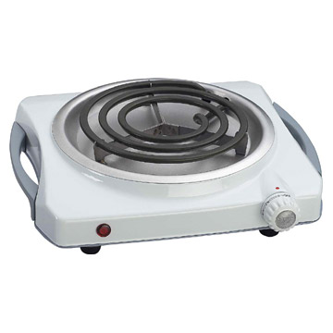 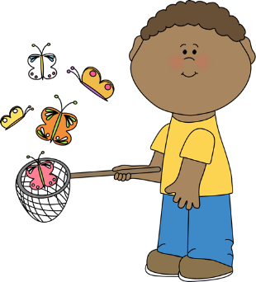

Tool:

Used For:

Tool:

Used For:

Tool:

Used For:

 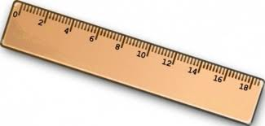 

Tool:

Used For:

Tool:

Used For:

Tool:

Used For:

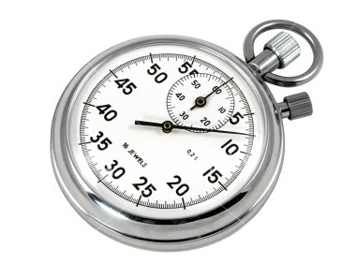 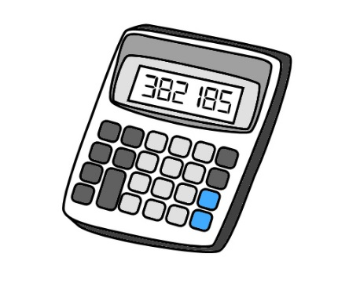 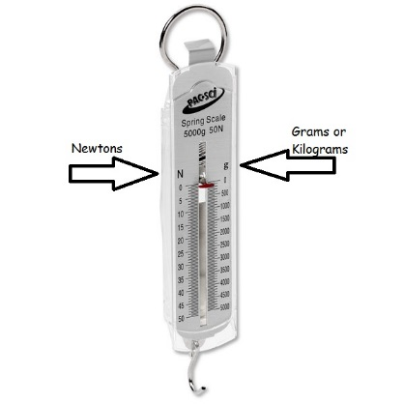

Tool:

Used For:

Tool:

Used For:

Tool:

Used For: