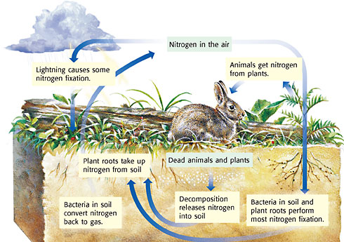

Refer to page 78 in your textbook

Refer to page 78 in your textbook

