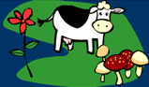 NICHE
What is your Niche?
A niche is a term that is used to describe the position of an organism and the role it plays within its ecosystem. It states the relationship that an organism has with other organisms and its surroundings.

