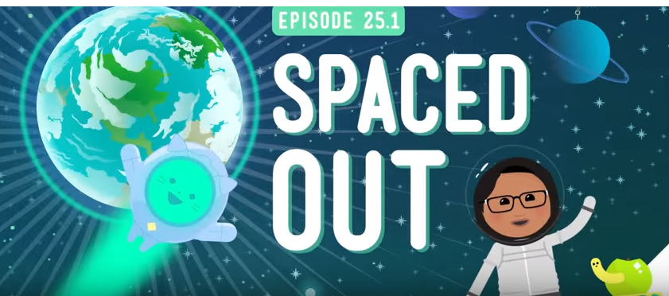
Crash Course – Spaced Out/Universe
- The _________________ is really BIG!
- Your _________________address is where you live in the Universe.
- Distances in space are so large that Scientists had to come up with a whole new way of ____________________ them.
- A ____________________ is the distance light can travel in one year.
- The observable universe is the parts that we can actually _____________, or observe in any direction.
- The sun is the closest ___________ to Earth.
- The second closest star to Earth would be ____________________ which is 4.24 light-years away. (It takes light a little over 4 years to reach us)
- The sun’s light takes only _____ minutes to reach us.
- The observable universe is _______ million light years across.
- We should know where we are in the ________________.

