Chloroplasts
By Erin Horner

 | energy | chemical | photosynthesis
 | this | every | pigment
 | chloroplasts | different | cells
 | able | living | organelle
 | cell | some | process
 | without | these

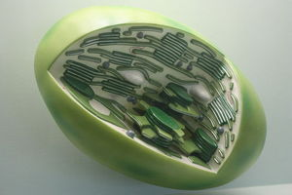
Directions: Fill in each blank with the word that best completes the reading comprehension.
(1) _______________________ (2) _______________________ thing is made up of cells. (3) _______________________ are animal cells. Others are made up of plant cells. Inside each (4) _______________________ are organelles. (5) _______________________ means "little organ." Each of (6) _______________________ little organs has a (7) _______________________ function. One organelle is called a chloroplast. Chloroplasts are found only in plant (8) _______________________ . Inside each chloroplast is a (9) _______________________ called chlorophyll. It is a green (10) _______________________ that makes a plant appear green. Together, chloroplasts and chlorophyll have a very important job. They make it possible for plants to absorb the (11) _______________________ from the sun. (12) _______________________ energy is used during (13) _______________________ , the (14) _______________________ that plants use to make the glucose that they use as food. (15) _______________________ (16) _______________________ , plants would not be (17) _______________________ to make their own food. A chloroplast may be a "little organ," but it has a big job!

Copyright © 2013 edHelper

1. Write one fact and one opinion about chloroplasts. | 2. What is the main idea of this passage? Organelles called chloroplasts play an important role in plant life. All cells create their own food. All living things contain cells. Photosynthesis uses energy from the sun.
3. What is one fact from the story? Organelles have big jobs. A plant cell contains more than one type of organelle. All cells are complex. Animal cells are simpler than plant cells. | 4. Choose the best title. My Plant is Bigger Than Your Plant Chloroplasts: Organelles With a Big Name and a Big Job! It's Not Easy Being Green All Plants Produce Food

