1.4.6 Energy Flow Worksheet

What is an ecosystem?

An ecosystem is a _________________________________________ with ___________________ and their __________________________ within _____________________, e.g. woodland, etc.

Energy Flow

Ecosystems are unable to function unless there is a constant ________________________________ _____________________.

Where does this energy come from? __________________

The Sun

The sun is the _________________________________________________ for our planet.

Energy Flow

is the _________________________________________________ from one organism to the next in an ecosystem due to ________________, e.g. along a food chain

Feeding allows _____________________________________________________ in an ecosystem.

Energy flow in the ecosystem
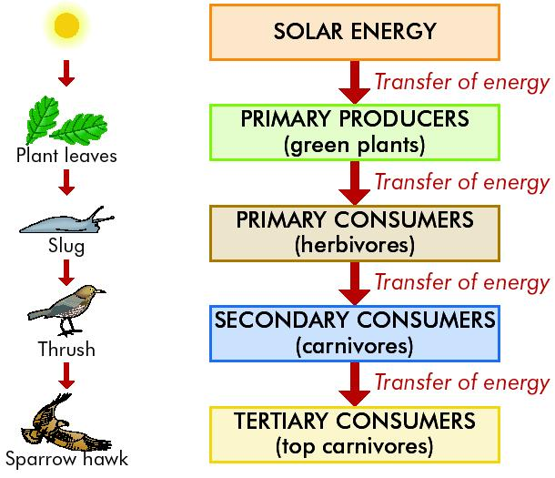

Food Chain

Is a flow diagram that begins with a _______________ and shows how _____________________ is passed through a series of ______________________________________.

Each organism feeds on the one before it.

A food chain ends when there is _____________________________________________________.

An example of a food chain:

__________ → ____________ → ______

A Grazing food chain

is one where the __________________________________ e.g.

________________ → grasshoppers → frogs → hawks

________________ → aphids → ladybirds → thrushes

________________ → winkles → crabs → herring gulls

________________ → zooplankton → copepod → herring

Grazing Food Chains
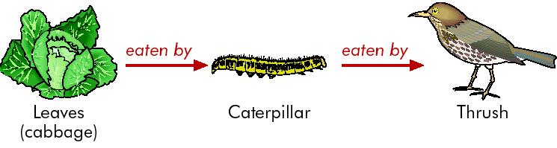

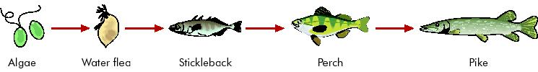

A Detritus food chain

is one where the chain begins with ________________________________________________ e.g.

___________________ → edible crab → seagull

___________________ → earthworms → blackbirds → hawks

Detritus Food Chain
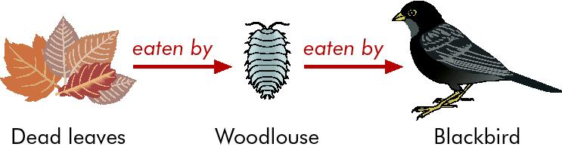

Food Web

This is a chart showing all the _______________________________________________________.

Constructed by showing the links between all the interconnecting food chains in the habitat.

Food Web

the interconnected food chains in an ecosystem e.g.
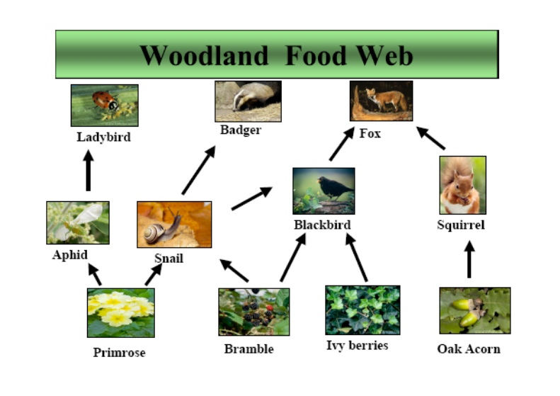

A woodland food web
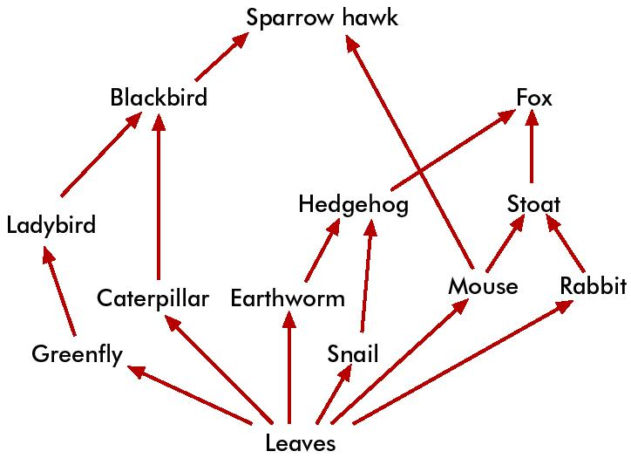

Construct two food chains (4 ‘links’) from the above food web

Another food web
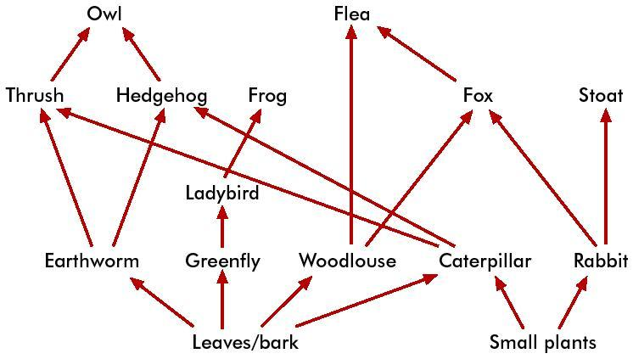

What is the longest food chain you can construct from this food web?
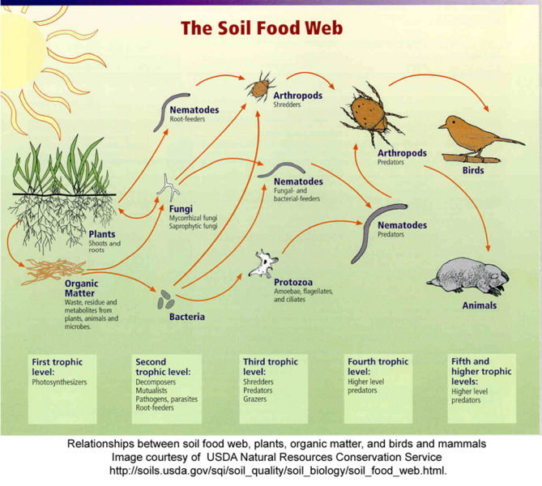

Producers

Producers are organisms capable of making ___________________________________________, e.g. green plants.

Primary producers are the _________________________________________________________

Consumers

Consumers are organisms that __________________________________________. They cannot _____________________________________. There are three types:

Primary consumers – feed on ______________________

Secondary consumers – feed on ______________________

Tertiary consumers – feed on ______________________

Woodland food chain

Honeysuckle → aphids → ladybirds → thrushes
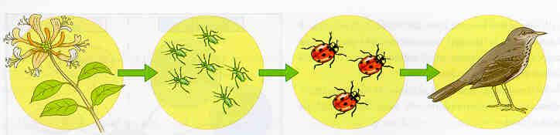

Primary consumer
Secondary consumer
Tertiary consumer
Producer

Trophic Level

This refers to the __________________________________ in a food chain.

__________________ are at the 1st trophic level (T1) and

__________________ occupy the 2nd trophic level (T2).

__________________ that eat herbivores are at the 3rd trophic level (T3).

The 4th trophic level (T4) is often occupied by the __________________________.

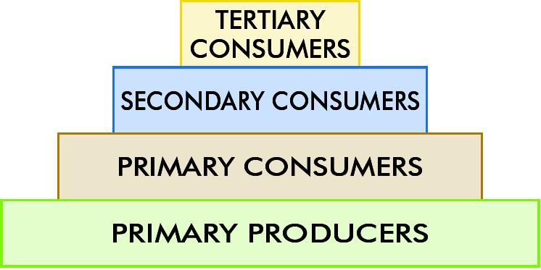
Trophic levels

Pyramid of Numbers

A diagram that represents the ________________________________ at each _________________ in _________________________.

Bottom layer is the ________________ and represents a very large number of _________________

The next layer ________________ and represents a smaller number of _______________________

The next layer – the number of ________________________

The uppermost layer where there may be only one __________________________________

Pyramid of Numbers
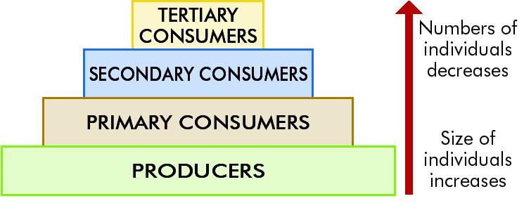

To construct a pyramid of numbers

Count the ______________________ and place them at the _________________________

Count each _________________ and include them according to their status (______________ or _________________ consumer) in the pyramid

The _________________________________ should include tertiary or top carnivores

Draw the pyramid so that the _____________________ of each level __________________ to the ______________________________________

Need to know

Name the sun as the primary source of energy.

Name feeding as the pathway of energy flow.

Present a grazing food chain.

Present a food web.

Construct a pyramid of numbers and explain its use.

END

